CONTENT:- PAGE NO.

1. PHYSICAL DATA MODEL ADVENTURE WORKS 2017 2
2. PHYSICAL DATA MODEL ADVENTURE WORKS DW 2017 2
3. SUB MODELS AND LIST OF TABLES - ADVENTURE WORKS 2017 3
4. SALES 3
5. INVENTORY 4
6. PURCHASING 5
7. SUB MODELS AND LIST OF TABLES - ADVENTURE WORKS DW 2017 6
8. RESELLER 6
9. INVENTORY 7
10. INTERNET SALES 8
11. DDL SCRIPT **SQL SERVER** ADVENTURE WORKS DW 2017 9
12. DDL SCRIPT **MYSQL** ADVENTURE WORKS DW 2017 62
13. DDL SCRIPT **POSTGRE SQL** ADVENTURE WORKS DW 2017 108
14. DDL SCRIPT **ORACLE** ADVENTURE WORKS DW2017 154
15. PHYSICAL DATA MODEL FOR ADVENTURE WORKS 2017

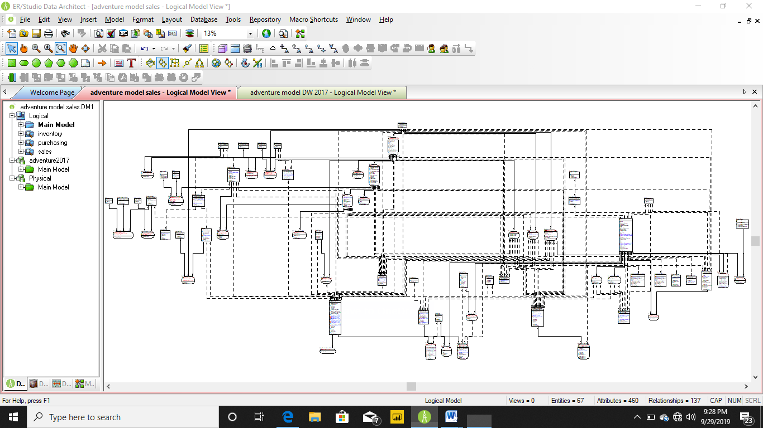

1. PHYSICAL DATA MODEL FOR ADVENTURE WORKS DW 2017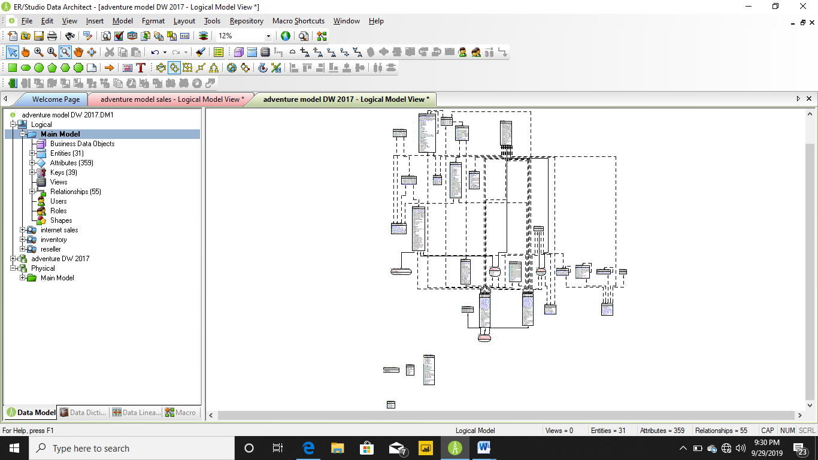
2. SUB MODELS AND LIST OF TABLES - ADVENTURE WORKS 2017
3. SALES

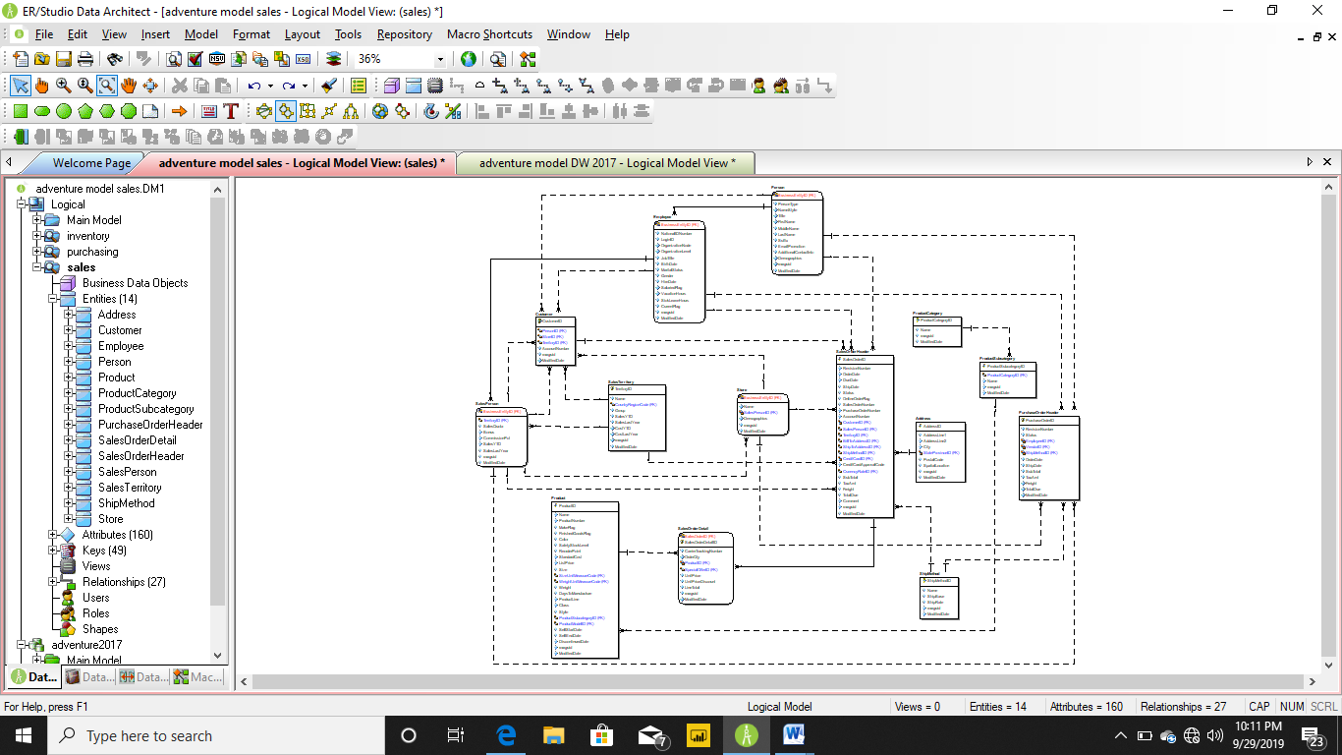

TABLES IN SALES

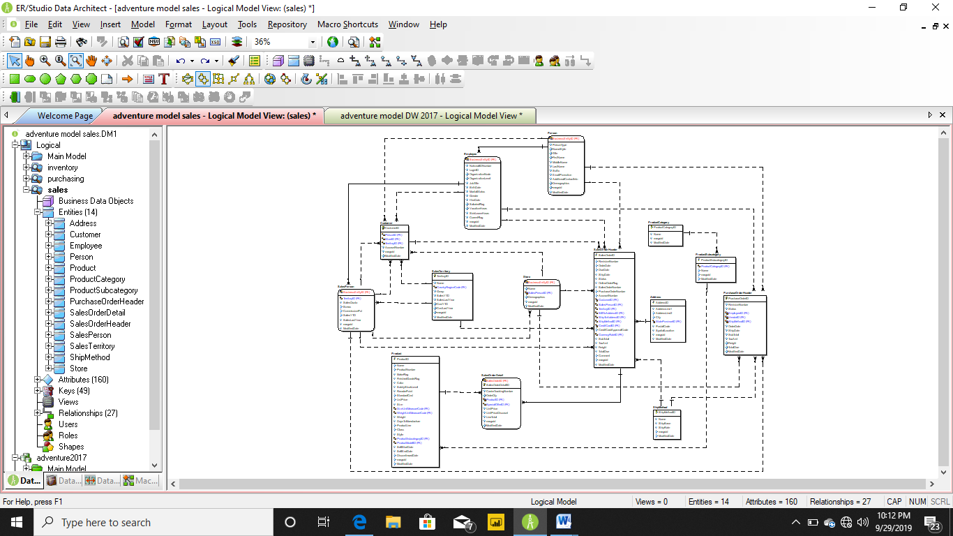

1. INVENTORY

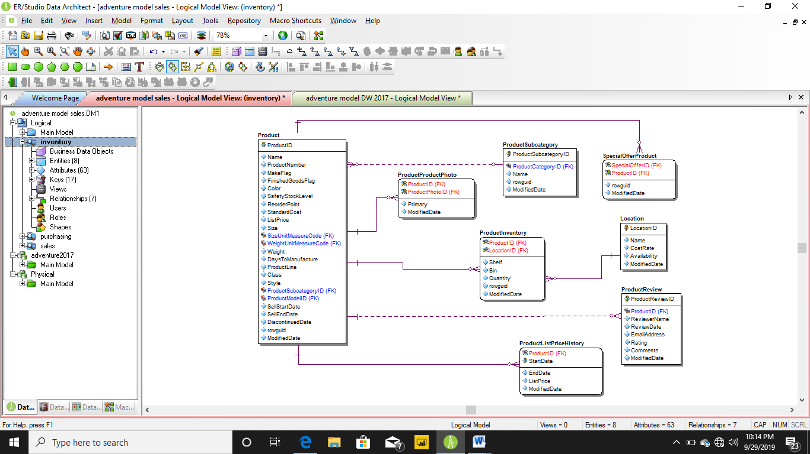

TABLES IN INVENTORY

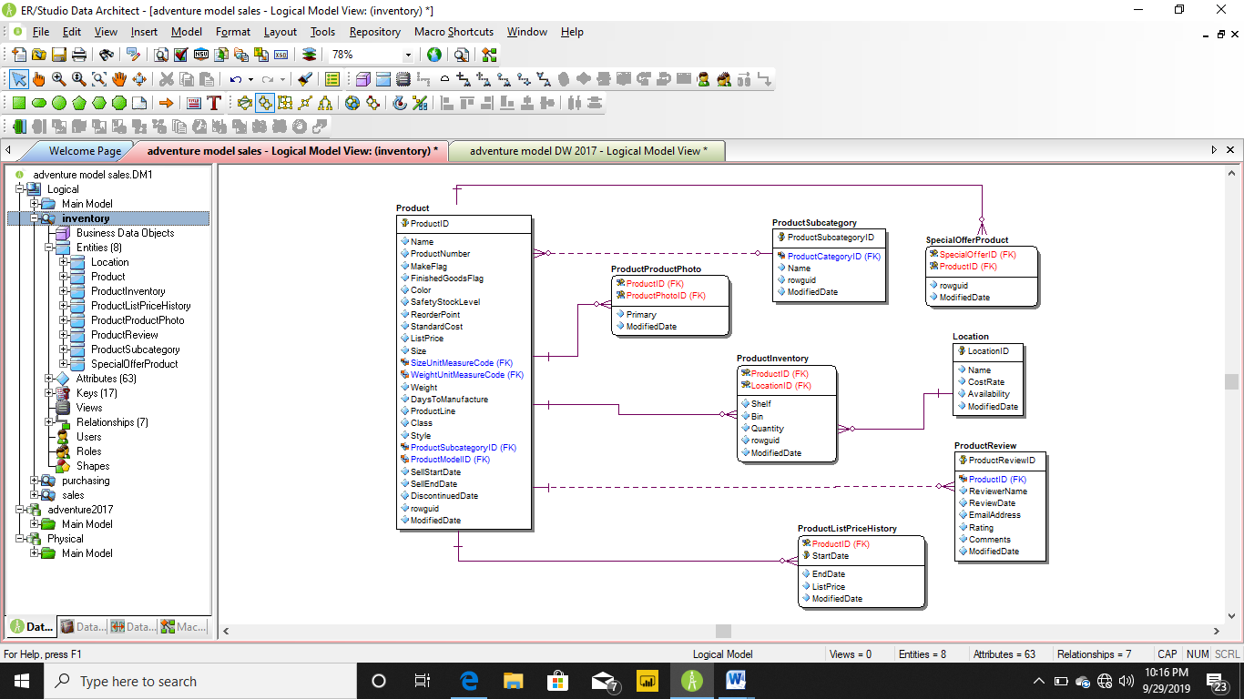

1. PURCHASING

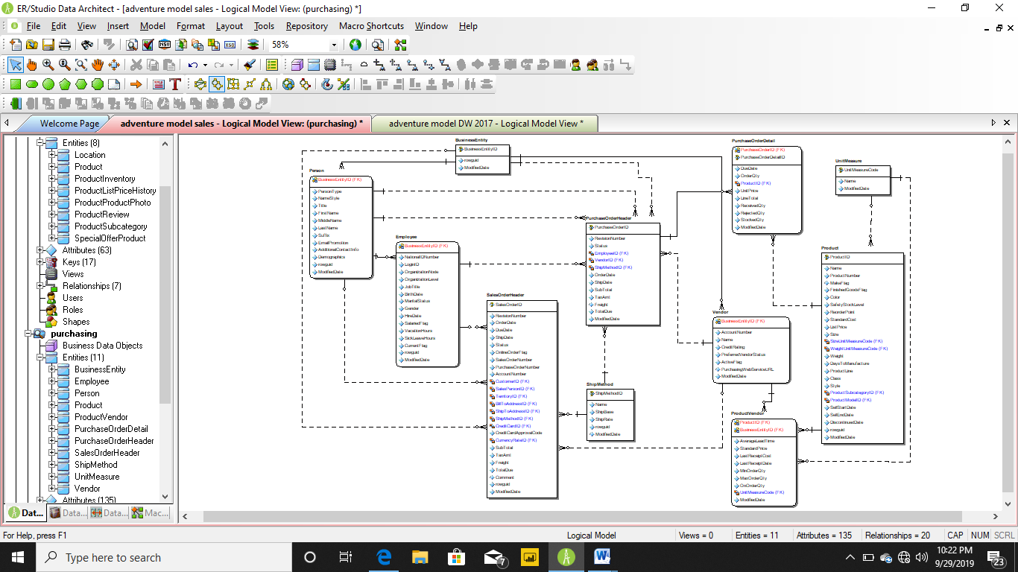

TABLES IN PURCHASING



1. SUB MODELS AND LIST OF TABLES - ADVENTURE WORKS DW 2017
2. RESELLER

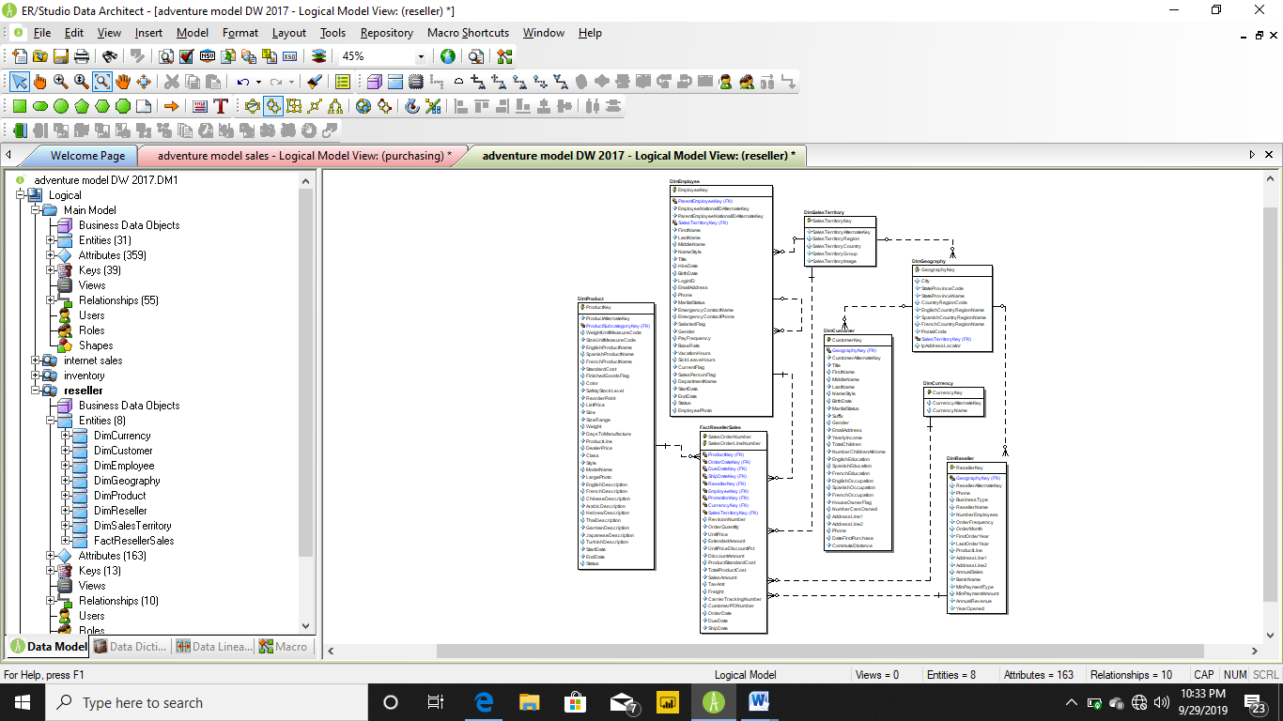

TABLES OF RESELLER

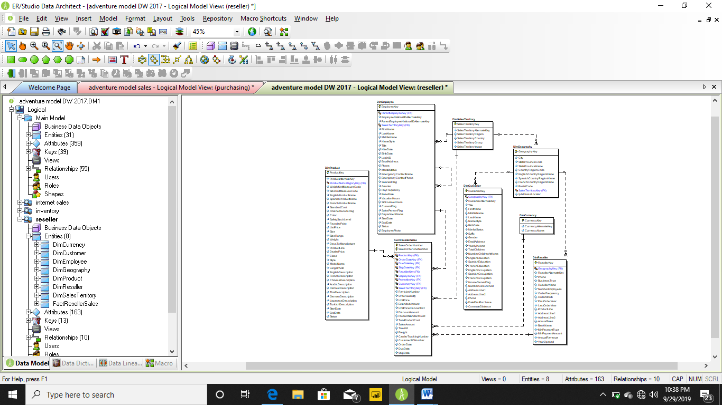

1. INVENTORY

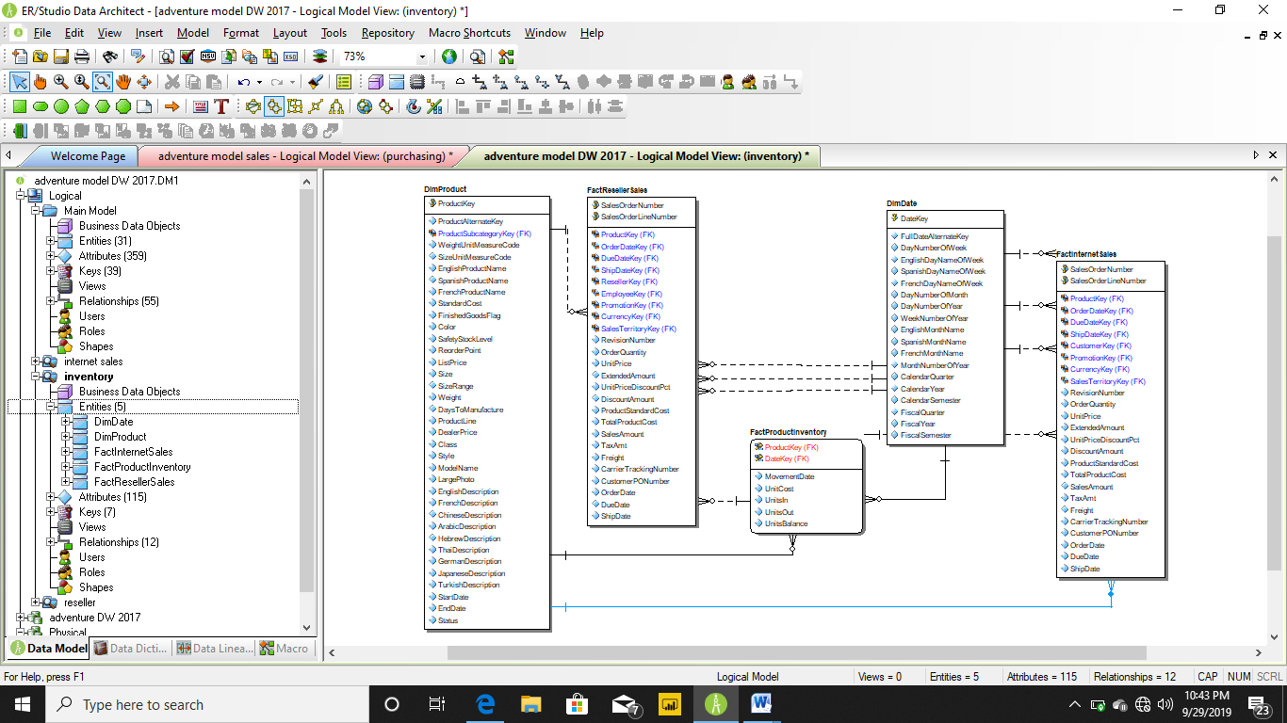

TABLES IN INVENTORY



1. INTERNET SALES

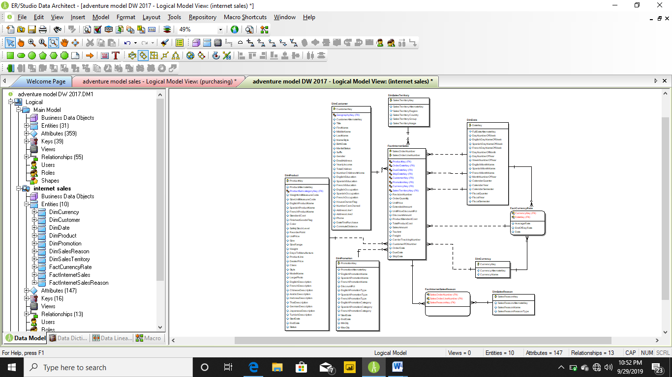

TABLES OF INTERNET SALES



1. DDL SCRIPT **SQL SERVER** ADVENTURE WORKS DW 2017

CREATE TABLE AdventureWorksDWBuildVersion(

DBVersion nvarchar(50) NULL,

VersionDate datetime NULL

)

go

IF OBJECT_ID('AdventureWorksDWBuildVersion') IS NOT NULL

PRINT '<<< CREATED TABLE AdventureWorksDWBuildVersion >>>'

ELSE

PRINT '<<< FAILED CREATING TABLE AdventureWorksDWBuildVersion >>>'

go

/*

* TABLE: DatabaseLog

*/

CREATE TABLE DatabaseLog(

DatabaseLogID int IDENTITY(1,1),

PostTime datetime NOT NULL,

DatabaseUser char(10) NOT NULL,

Event char(10) NOT NULL,

Schema char(10) NULL,

Object char(10) NULL,

TSQL nvarchar(max) NOT NULL,

XmlEvent xml NOT NULL,

CONSTRAINT PK_DatabaseLog_DatabaseLogID PRIMARY KEY NONCLUSTERED (DatabaseLogID)

)

go

IF OBJECT_ID('DatabaseLog') IS NOT NULL

PRINT '<<< CREATED TABLE DatabaseLog >>>'

ELSE

PRINT '<<< FAILED CREATING TABLE DatabaseLog >>>'

go

/*

* TABLE: DimAccount

*/

CREATE TABLE DimAccount(

AccountKey int IDENTITY(1,1),

ParentAccountKey int NULL,

AccountCodeAlternateKey int NULL,

ParentAccountCodeAlternateKey int NULL,

AccountDescription nvarchar(50) NULL,

AccountType nvarchar(50) NULL,

Operator nvarchar(50) NULL,

CustomMembers nvarchar(300) NULL,

ValueType nvarchar(50) NULL,

CustomMemberOptions nvarchar(200) NULL,

CONSTRAINT PK_DimAccount PRIMARY KEY CLUSTERED (AccountKey)

)

go

IF OBJECT_ID('DimAccount') IS NOT NULL

PRINT '<<< CREATED TABLE DimAccount >>>'

ELSE

PRINT '<<< FAILED CREATING TABLE DimAccount >>>'

go

/*

* TABLE: DimCurrency

*/

CREATE TABLE DimCurrency(

CurrencyKey int IDENTITY(1,1),

CurrencyAlternateKey nchar(3) NOT NULL,

CurrencyName nvarchar(50) NOT NULL,

CONSTRAINT PK_DimCurrency_CurrencyKey PRIMARY KEY CLUSTERED (CurrencyKey)

)

go

IF OBJECT_ID('DimCurrency') IS NOT NULL

PRINT '<<< CREATED TABLE DimCurrency >>>'

ELSE

PRINT '<<< FAILED CREATING TABLE DimCurrency >>>'

go

/*

* TABLE: DimCustomer

*/

CREATE TABLE DimCustomer(

CustomerKey int IDENTITY(1,1),

GeographyKey int NULL,

CustomerAlternateKey nvarchar(15) NOT NULL,

Title nvarchar(8) NULL,

FirstName nvarchar(50) NULL,

MiddleName nvarchar(50) NULL,

LastName nvarchar(50) NULL,

NameStyle bit NULL,

BirthDate date NULL,

MaritalStatus nchar(1) NULL,

Suffix nvarchar(10) NULL,

Gender nvarchar(1) NULL,

EmailAddress nvarchar(50) NULL,

YearlyIncome money NULL,

TotalChildren tinyint NULL,

NumberChildrenAtHome tinyint NULL,

EnglishEducation nvarchar(40) NULL,

SpanishEducation nvarchar(40) NULL,

FrenchEducation nvarchar(40) NULL,

EnglishOccupation nvarchar(100) NULL,

SpanishOccupation nvarchar(100) NULL,

FrenchOccupation nvarchar(100) NULL,

HouseOwnerFlag nchar(1) NULL,

NumberCarsOwned tinyint NULL,

AddressLine1 nvarchar(120) NULL,

AddressLine2 nvarchar(120) NULL,

Phone nvarchar(20) NULL,

DateFirstPurchase date NULL,

CommuteDistance nvarchar(15) NULL,

CONSTRAINT PK_DimCustomer_CustomerKey PRIMARY KEY CLUSTERED (CustomerKey)

)

go

IF OBJECT_ID('DimCustomer') IS NOT NULL

PRINT '<<< CREATED TABLE DimCustomer >>>'

ELSE

PRINT '<<< FAILED CREATING TABLE DimCustomer >>>'

go

/*

* TABLE: DimDate

*/

CREATE TABLE DimDate(

DateKey int NOT NULL,

FullDateAlternateKey date NOT NULL,

DayNumberOfWeek tinyint NOT NULL,

EnglishDayNameOfWeek nvarchar(10) NOT NULL,

SpanishDayNameOfWeek nvarchar(10) NOT NULL,

FrenchDayNameOfWeek nvarchar(10) NOT NULL,

DayNumberOfMonth tinyint NOT NULL,

DayNumberOfYear smallint NOT NULL,

WeekNumberOfYear tinyint NOT NULL,

EnglishMonthName nvarchar(10) NOT NULL,

SpanishMonthName nvarchar(10) NOT NULL,

FrenchMonthName nvarchar(10) NOT NULL,

MonthNumberOfYear tinyint NOT NULL,

CalendarQuarter tinyint NOT NULL,

CalendarYear smallint NOT NULL,

CalendarSemester tinyint NOT NULL,

FiscalQuarter tinyint NOT NULL,

FiscalYear smallint NOT NULL,

FiscalSemester tinyint NOT NULL,

CONSTRAINT PK_DimDate_DateKey PRIMARY KEY CLUSTERED (DateKey)

)

go

IF OBJECT_ID('DimDate') IS NOT NULL

PRINT '<<< CREATED TABLE DimDate >>>'

ELSE

PRINT '<<< FAILED CREATING TABLE DimDate >>>'

go

/*

* TABLE: DimDepartmentGroup

*/

CREATE TABLE DimDepartmentGroup(

DepartmentGroupKey int IDENTITY(1,1),

ParentDepartmentGroupKey int NULL,

DepartmentGroupName nvarchar(50) NULL,

CONSTRAINT PK_DimDepartmentGroup PRIMARY KEY CLUSTERED (DepartmentGroupKey)

)

go

IF OBJECT_ID('DimDepartmentGroup') IS NOT NULL

PRINT '<<< CREATED TABLE DimDepartmentGroup >>>'

ELSE

PRINT '<<< FAILED CREATING TABLE DimDepartmentGroup >>>'

go

/*

* TABLE: DimEmployee

*/

CREATE TABLE DimEmployee(

EmployeeKey int IDENTITY(1,1),

ParentEmployeeKey int NULL,

EmployeeNationalIDAlternateKey nvarchar(15) NULL,

ParentEmployeeNationalIDAlternateKey nvarchar(15) NULL,

SalesTerritoryKey int NULL,

FirstName nvarchar(50) NOT NULL,

LastName nvarchar(50) NOT NULL,

MiddleName nvarchar(50) NULL,

NameStyle bit NOT NULL,

Title nvarchar(50) NULL,

HireDate date NULL,

BirthDate date NULL,

LoginID nvarchar(256) NULL,

EmailAddress nvarchar(50) NULL,

Phone nvarchar(25) NULL,

MaritalStatus nchar(1) NULL,

EmergencyContactName nvarchar(50) NULL,

EmergencyContactPhone nvarchar(25) NULL,

SalariedFlag bit NULL,

Gender nchar(1) NULL,

PayFrequency tinyint NULL,

BaseRate money NULL,

VacationHours smallint NULL,

SickLeaveHours smallint NULL,

CurrentFlag bit NOT NULL,

SalesPersonFlag bit NOT NULL,

DepartmentName nvarchar(50) NULL,

StartDate date NULL,

EndDate date NULL,

Status nvarchar(50) NULL,

EmployeePhoto varbinary(max) NULL,

CONSTRAINT PK_DimEmployee_EmployeeKey PRIMARY KEY CLUSTERED (EmployeeKey)

)

go

IF OBJECT_ID('DimEmployee') IS NOT NULL

PRINT '<<< CREATED TABLE DimEmployee >>>'

ELSE

PRINT '<<< FAILED CREATING TABLE DimEmployee >>>'

go

/*

* TABLE: DimGeography

*/

CREATE TABLE DimGeography(

GeographyKey int IDENTITY(1,1),

City nvarchar(30) NULL,

StateProvinceCode nvarchar(3) NULL,

StateProvinceName nvarchar(50) NULL,

CountryRegionCode nvarchar(3) NULL,

EnglishCountryRegionName nvarchar(50) NULL,

SpanishCountryRegionName nvarchar(50) NULL,

FrenchCountryRegionName nvarchar(50) NULL,

PostalCode nvarchar(15) NULL,

SalesTerritoryKey int NULL,

IpAddressLocator nvarchar(15) NULL,

CONSTRAINT PK_DimGeography_GeographyKey PRIMARY KEY CLUSTERED (GeographyKey)

)

go

IF OBJECT_ID('DimGeography') IS NOT NULL

PRINT '<<< CREATED TABLE DimGeography >>>'

ELSE

PRINT '<<< FAILED CREATING TABLE DimGeography >>>'

go

/*

* TABLE: DimOrganization

*/

CREATE TABLE DimOrganization(

OrganizationKey int IDENTITY(1,1),

ParentOrganizationKey int NULL,

PercentageOfOwnership nvarchar(16) NULL,

OrganizationName nvarchar(50) NULL,

CurrencyKey int NULL,

CONSTRAINT PK_DimOrganization PRIMARY KEY CLUSTERED (OrganizationKey)

)

go

IF OBJECT_ID('DimOrganization') IS NOT NULL

PRINT '<<< CREATED TABLE DimOrganization >>>'

ELSE

PRINT '<<< FAILED CREATING TABLE DimOrganization >>>'

go

/*

* TABLE: DimProduct

*/

CREATE TABLE DimProduct(

ProductKey int IDENTITY(1,1),

ProductAlternateKey nvarchar(25) NULL,

ProductSubcategoryKey int NULL,

WeightUnitMeasureCode nchar(3) NULL,

SizeUnitMeasureCode nchar(3) NULL,

EnglishProductName nvarchar(50) NOT NULL,

SpanishProductName nvarchar(50) NOT NULL,

FrenchProductName nvarchar(50) NOT NULL,

StandardCost money NULL,

FinishedGoodsFlag bit NOT NULL,

Color nvarchar(15) NOT NULL,

SafetyStockLevel smallint NULL,

ReorderPoint smallint NULL,

ListPrice money NULL,

Size nvarchar(50) NULL,

SizeRange nvarchar(50) NULL,

Weight float NULL,

DaysToManufacture int NULL,

ProductLine nchar(2) NULL,

DealerPrice money NULL,

Class nchar(2) NULL,

Style nchar(2) NULL,

ModelName nvarchar(50) NULL,

LargePhoto varbinary(max) NULL,

EnglishDescription nvarchar(400) NULL,

FrenchDescription nvarchar(400) NULL,

ChineseDescription nvarchar(400) NULL,

ArabicDescription nvarchar(400) NULL,

HebrewDescription nvarchar(400) NULL,

ThaiDescription nvarchar(400) NULL,

GermanDescription nvarchar(400) NULL,

JapaneseDescription nvarchar(400) NULL,

TurkishDescription nvarchar(400) NULL,

StartDate datetime NULL,

EndDate datetime NULL,

Status nvarchar(7) NULL,

CONSTRAINT PK_DimProduct_ProductKey PRIMARY KEY CLUSTERED (ProductKey),

CONSTRAINT AK_DimProduct_ProductAlternateKey_StartDate UNIQUE (ProductAlternateKey, StartDate)

)

go

IF OBJECT_ID('DimProduct') IS NOT NULL

PRINT '<<< CREATED TABLE DimProduct >>>'

ELSE

PRINT '<<< FAILED CREATING TABLE DimProduct >>>'

go

/*

* TABLE: DimProductCategory

*/

CREATE TABLE DimProductCategory(

ProductCategoryKey int IDENTITY(1,1),

ProductCategoryAlternateKey int NULL,

EnglishProductCategoryName nvarchar(50) NOT NULL,

SpanishProductCategoryName nvarchar(50) NOT NULL,

FrenchProductCategoryName nvarchar(50) NOT NULL,

CONSTRAINT PK_DimProductCategory_ProductCategoryKey PRIMARY KEY CLUSTERED (ProductCategoryKey),

CONSTRAINT AK_DimProductCategory_ProductCategoryAlternateKey UNIQUE (ProductCategoryAlternateKey)

)

go

IF OBJECT_ID('DimProductCategory') IS NOT NULL

PRINT '<<< CREATED TABLE DimProductCategory >>>'

ELSE

PRINT '<<< FAILED CREATING TABLE DimProductCategory >>>'

go

/*

* TABLE: DimProductSubcategory

*/

CREATE TABLE DimProductSubcategory(

ProductSubcategoryKey int IDENTITY(1,1),

ProductSubcategoryAlternateKey int NULL,

EnglishProductSubcategoryName nvarchar(50) NOT NULL,

SpanishProductSubcategoryName nvarchar(50) NOT NULL,

FrenchProductSubcategoryName nvarchar(50) NOT NULL,

ProductCategoryKey int NULL,

CONSTRAINT PK_DimProductSubcategory_ProductSubcategoryKey PRIMARY KEY CLUSTERED (ProductSubcategoryKey),

CONSTRAINT AK_DimProductSubcategory_ProductSubcategoryAlternateKey UNIQUE (ProductSubcategoryAlternateKey)

)

go

IF OBJECT_ID('DimProductSubcategory') IS NOT NULL

PRINT '<<< CREATED TABLE DimProductSubcategory >>>'

ELSE

PRINT '<<< FAILED CREATING TABLE DimProductSubcategory >>>'

go

/*

* TABLE: DimPromotion

*/

CREATE TABLE DimPromotion(

PromotionKey int IDENTITY(1,1),

PromotionAlternateKey int NULL,

EnglishPromotionName nvarchar(255) NULL,

SpanishPromotionName nvarchar(255) NULL,

FrenchPromotionName nvarchar(255) NULL,

DiscountPct float NULL,

EnglishPromotionType nvarchar(50) NULL,

SpanishPromotionType nvarchar(50) NULL,

FrenchPromotionType nvarchar(50) NULL,

EnglishPromotionCategory nvarchar(50) NULL,

SpanishPromotionCategory nvarchar(50) NULL,

FrenchPromotionCategory nvarchar(50) NULL,

StartDate datetime NOT NULL,

EndDate datetime NULL,

MinQty int NULL,

MaxQty int NULL,

CONSTRAINT PK_DimPromotion_PromotionKey PRIMARY KEY CLUSTERED (PromotionKey),

CONSTRAINT AK_DimPromotion_PromotionAlternateKey UNIQUE (PromotionAlternateKey)

)

go

IF OBJECT_ID('DimPromotion') IS NOT NULL

PRINT '<<< CREATED TABLE DimPromotion >>>'

ELSE

PRINT '<<< FAILED CREATING TABLE DimPromotion >>>'

go

/*

* TABLE: DimReseller

*/

CREATE TABLE DimReseller(

ResellerKey int IDENTITY(1,1),

GeographyKey int NULL,

ResellerAlternateKey nvarchar(15) NULL,

Phone nvarchar(25) NULL,

BusinessType varchar(20) NOT NULL,

ResellerName nvarchar(50) NOT NULL,

NumberEmployees int NULL,

OrderFrequency char(1) NULL,

OrderMonth tinyint NULL,

FirstOrderYear int NULL,

LastOrderYear int NULL,

ProductLine nvarchar(50) NULL,

AddressLine1 nvarchar(60) NULL,

AddressLine2 nvarchar(60) NULL,

AnnualSales money NULL,

BankName nvarchar(50) NULL,

MinPaymentType tinyint NULL,

MinPaymentAmount money NULL,

AnnualRevenue money NULL,

YearOpened int NULL,

CONSTRAINT PK_DimReseller_ResellerKey PRIMARY KEY CLUSTERED (ResellerKey),

CONSTRAINT AK_DimReseller_ResellerAlternateKey UNIQUE (ResellerAlternateKey)

)

go

IF OBJECT_ID('DimReseller') IS NOT NULL

PRINT '<<< CREATED TABLE DimReseller >>>'

ELSE

PRINT '<<< FAILED CREATING TABLE DimReseller >>>'

go

/*

* TABLE: DimSalesReason

*/

CREATE TABLE DimSalesReason(

SalesReasonKey int IDENTITY(1,1),

SalesReasonAlternateKey int NOT NULL,

SalesReasonName nvarchar(50) NOT NULL,

SalesReasonReasonType nvarchar(50) NOT NULL,

CONSTRAINT PK_DimSalesReason_SalesReasonKey PRIMARY KEY CLUSTERED (SalesReasonKey)

)

go

IF OBJECT_ID('DimSalesReason') IS NOT NULL

PRINT '<<< CREATED TABLE DimSalesReason >>>'

ELSE

PRINT '<<< FAILED CREATING TABLE DimSalesReason >>>'

go

/*

* TABLE: DimSalesTerritory

*/

CREATE TABLE DimSalesTerritory(

SalesTerritoryKey int IDENTITY(1,1),

SalesTerritoryAlternateKey int NULL,

SalesTerritoryRegion nvarchar(50) NOT NULL,

SalesTerritoryCountry nvarchar(50) NOT NULL,

SalesTerritoryGroup nvarchar(50) NULL,

SalesTerritoryImage varbinary(max) NULL,

CONSTRAINT PK_DimSalesTerritory_SalesTerritoryKey PRIMARY KEY CLUSTERED (SalesTerritoryKey),

CONSTRAINT AK_DimSalesTerritory_SalesTerritoryAlternateKey UNIQUE (SalesTerritoryAlternateKey)

)

go

IF OBJECT_ID('DimSalesTerritory') IS NOT NULL

PRINT '<<< CREATED TABLE DimSalesTerritory >>>'

ELSE

PRINT '<<< FAILED CREATING TABLE DimSalesTerritory >>>'

go

/*

* TABLE: DimScenario

*/

CREATE TABLE DimScenario(

ScenarioKey int IDENTITY(1,1),

ScenarioName nvarchar(50) NULL,

CONSTRAINT PK_DimScenario PRIMARY KEY CLUSTERED (ScenarioKey)

)

go

IF OBJECT_ID('DimScenario') IS NOT NULL

PRINT '<<< CREATED TABLE DimScenario >>>'

ELSE

PRINT '<<< FAILED CREATING TABLE DimScenario >>>'

go

/*

* TABLE: FactAdditionalInternationalProductDescription

*/

CREATE TABLE FactAdditionalInternationalProductDescription(

ProductKey int NOT NULL,

CultureName nvarchar(50) NOT NULL,

ProductDescription nvarchar(max) NOT NULL,

CONSTRAINT PK_FactAdditionalInternationalProductDescription_ProductKey_CultureName PRIMARY KEY CLUSTERED (ProductKey, CultureName)

)

go

IF OBJECT_ID('FactAdditionalInternationalProductDescription') IS NOT NULL

PRINT '<<< CREATED TABLE FactAdditionalInternationalProductDescription >>>'

ELSE

PRINT '<<< FAILED CREATING TABLE FactAdditionalInternationalProductDescription >>>'

go

/*

* TABLE: FactCallCenter

*/

CREATE TABLE FactCallCenter(

FactCallCenterID int IDENTITY(1,1),

DateKey int NOT NULL,

WageType nvarchar(15) NOT NULL,

Shift nvarchar(20) NOT NULL,

LevelOneOperators smallint NOT NULL,

LevelTwoOperators smallint NOT NULL,

TotalOperators smallint NOT NULL,

Calls int NOT NULL,

AutomaticResponses int NOT NULL,

Orders int NOT NULL,

IssuesRaised smallint NOT NULL,

AverageTimePerIssue smallint NOT NULL,

ServiceGrade float NOT NULL,

Date datetime NULL,

CONSTRAINT PK_FactCallCenter_FactCallCenterID PRIMARY KEY CLUSTERED (FactCallCenterID),

CONSTRAINT AK_FactCallCenter_DateKey_Shift UNIQUE (DateKey, Shift)

)

go

IF OBJECT_ID('FactCallCenter') IS NOT NULL

PRINT '<<< CREATED TABLE FactCallCenter >>>'

ELSE

PRINT '<<< FAILED CREATING TABLE FactCallCenter >>>'

go

/*

* TABLE: FactCurrencyRate

*/

CREATE TABLE FactCurrencyRate(

CurrencyKey int NOT NULL,

DateKey int NOT NULL,

AverageRate float NOT NULL,

EndOfDayRate float NOT NULL,

Date datetime NULL,

CONSTRAINT PK_FactCurrencyRate_CurrencyKey_DateKey PRIMARY KEY CLUSTERED (CurrencyKey, DateKey)

)

go

IF OBJECT_ID('FactCurrencyRate') IS NOT NULL

PRINT '<<< CREATED TABLE FactCurrencyRate >>>'

ELSE

PRINT '<<< FAILED CREATING TABLE FactCurrencyRate >>>'

go

/*

* TABLE: FactFinance

*/

CREATE TABLE FactFinance(

FinanceKey int IDENTITY(1,1),

DateKey int NOT NULL,

OrganizationKey int NOT NULL,

DepartmentGroupKey int NOT NULL,

ScenarioKey int NOT NULL,

AccountKey int NOT NULL,

Amount float NOT NULL,

Date datetime NULL

)

go

IF OBJECT_ID('FactFinance') IS NOT NULL

PRINT '<<< CREATED TABLE FactFinance >>>'

ELSE

PRINT '<<< FAILED CREATING TABLE FactFinance >>>'

go

/*

* TABLE: FactInternetSales

*/

CREATE TABLE FactInternetSales(

ProductKey int NOT NULL,

OrderDateKey int NOT NULL,

DueDateKey int NOT NULL,

ShipDateKey int NOT NULL,

CustomerKey int NOT NULL,

PromotionKey int NOT NULL,

CurrencyKey int NOT NULL,

SalesTerritoryKey int NOT NULL,

SalesOrderNumber nvarchar(20) NOT NULL,

SalesOrderLineNumber tinyint NOT NULL,

RevisionNumber tinyint NOT NULL,

OrderQuantity smallint NOT NULL,

UnitPrice money NOT NULL,

ExtendedAmount money NOT NULL,

UnitPriceDiscountPct float NOT NULL,

DiscountAmount float NOT NULL,

ProductStandardCost money NOT NULL,

TotalProductCost money NOT NULL,

SalesAmount money NOT NULL,

TaxAmt money NOT NULL,

Freight money NOT NULL,

CarrierTrackingNumber nvarchar(25) NULL,

CustomerPONumber nvarchar(25) NULL,

OrderDate datetime NULL,

DueDate datetime NULL,

ShipDate datetime NULL,

CONSTRAINT PK_FactInternetSales_SalesOrderNumber_SalesOrderLineNumber PRIMARY KEY CLUSTERED (SalesOrderNumber, SalesOrderLineNumber)

)

go

IF OBJECT_ID('FactInternetSales') IS NOT NULL

PRINT '<<< CREATED TABLE FactInternetSales >>>'

ELSE

PRINT '<<< FAILED CREATING TABLE FactInternetSales >>>'

go

/*

* TABLE: FactInternetSalesReason

*/

CREATE TABLE FactInternetSalesReason(

SalesOrderNumber nvarchar(20) NOT NULL,

SalesOrderLineNumber tinyint NOT NULL,

SalesReasonKey int NOT NULL,

CONSTRAINT PK_FactInternetSalesReason_SalesOrderNumber_SalesOrderLineNumber_SalesReasonKey PRIMARY KEY CLUSTERED (SalesOrderNumber, SalesOrderLineNumber, SalesReasonKey)

)

go

IF OBJECT_ID('FactInternetSalesReason') IS NOT NULL

PRINT '<<< CREATED TABLE FactInternetSalesReason >>>'

ELSE

PRINT '<<< FAILED CREATING TABLE FactInternetSalesReason >>>'

go

/*

* TABLE: FactProductInventory

*/

CREATE TABLE FactProductInventory(

ProductKey int NOT NULL,

DateKey int NOT NULL,

MovementDate date NOT NULL,

UnitCost money NOT NULL,

UnitsIn int NOT NULL,

UnitsOut int NOT NULL,

UnitsBalance int NOT NULL,

CONSTRAINT PK_FactProductInventory PRIMARY KEY CLUSTERED (ProductKey, DateKey)

)

go

IF OBJECT_ID('FactProductInventory') IS NOT NULL

PRINT '<<< CREATED TABLE FactProductInventory >>>'

ELSE

PRINT '<<< FAILED CREATING TABLE FactProductInventory >>>'

go

/*

* TABLE: FactResellerSales

*/

CREATE TABLE FactResellerSales(

ProductKey int NOT NULL,

OrderDateKey int NOT NULL,

DueDateKey int NOT NULL,

ShipDateKey int NOT NULL,

ResellerKey int NOT NULL,

EmployeeKey int NOT NULL,

PromotionKey int NOT NULL,

CurrencyKey int NOT NULL,

SalesTerritoryKey int NOT NULL,

SalesOrderNumber nvarchar(20) NOT NULL,

SalesOrderLineNumber tinyint NOT NULL,

RevisionNumber tinyint NULL,

OrderQuantity smallint NULL,

UnitPrice money NULL,

ExtendedAmount money NULL,

UnitPriceDiscountPct float NULL,

DiscountAmount float NULL,

ProductStandardCost money NULL,

TotalProductCost money NULL,

SalesAmount money NULL,

TaxAmt money NULL,

Freight money NULL,

CarrierTrackingNumber nvarchar(25) NULL,

CustomerPONumber nvarchar(25) NULL,

OrderDate datetime NULL,

DueDate datetime NULL,

ShipDate datetime NULL,

CONSTRAINT PK_FactResellerSales_SalesOrderNumber_SalesOrderLineNumber PRIMARY KEY CLUSTERED (SalesOrderNumber, SalesOrderLineNumber)

)

go

IF OBJECT_ID('FactResellerSales') IS NOT NULL

PRINT '<<< CREATED TABLE FactResellerSales >>>'

ELSE

PRINT '<<< FAILED CREATING TABLE FactResellerSales >>>'

go

/*

* TABLE: FactSalesQuota

*/

CREATE TABLE FactSalesQuota(

SalesQuotaKey int IDENTITY(1,1),

EmployeeKey int NOT NULL,

DateKey int NOT NULL,

CalendarYear smallint NOT NULL,

CalendarQuarter tinyint NOT NULL,

SalesAmountQuota money NOT NULL,

Date datetime NULL,

CONSTRAINT PK_FactSalesQuota_SalesQuotaKey PRIMARY KEY CLUSTERED (SalesQuotaKey)

)

go

IF OBJECT_ID('FactSalesQuota') IS NOT NULL

PRINT '<<< CREATED TABLE FactSalesQuota >>>'

ELSE

PRINT '<<< FAILED CREATING TABLE FactSalesQuota >>>'

go

/*

* TABLE: FactSurveyResponse

*/

CREATE TABLE FactSurveyResponse(

SurveyResponseKey int IDENTITY(1,1),

DateKey int NOT NULL,

CustomerKey int NOT NULL,

ProductCategoryKey int NOT NULL,

EnglishProductCategoryName nvarchar(50) NOT NULL,

ProductSubcategoryKey int NOT NULL,

EnglishProductSubcategoryName nvarchar(50) NOT NULL,

Date datetime NULL,

CONSTRAINT PK_FactSurveyResponse_SurveyResponseKey PRIMARY KEY CLUSTERED (SurveyResponseKey)

)

go

IF OBJECT_ID('FactSurveyResponse') IS NOT NULL

PRINT '<<< CREATED TABLE FactSurveyResponse >>>'

ELSE

PRINT '<<< FAILED CREATING TABLE FactSurveyResponse >>>'

go

/*

* TABLE: NewFactCurrencyRate

*/

CREATE TABLE NewFactCurrencyRate(

AverageRate real NULL,

CurrencyID nvarchar(3) NULL,

CurrencyDate date NULL,

EndOfDayRate real NULL,

CurrencyKey int NULL,

DateKey int NULL

)

go

IF OBJECT_ID('NewFactCurrencyRate') IS NOT NULL

PRINT '<<< CREATED TABLE NewFactCurrencyRate >>>'

ELSE

PRINT '<<< FAILED CREATING TABLE NewFactCurrencyRate >>>'

go

/*

* TABLE: ProspectiveBuyer

*/

CREATE TABLE ProspectiveBuyer(

ProspectiveBuyerKey int IDENTITY(1,1),

ProspectAlternateKey nvarchar(15) NULL,

FirstName nvarchar(50) NULL,

MiddleName nvarchar(50) NULL,

LastName nvarchar(50) NULL,

BirthDate datetime NULL,

MaritalStatus nchar(1) NULL,

Gender nvarchar(1) NULL,

EmailAddress nvarchar(50) NULL,

YearlyIncome money NULL,

TotalChildren tinyint NULL,

NumberChildrenAtHome tinyint NULL,

Education nvarchar(40) NULL,

Occupation nvarchar(100) NULL,

HouseOwnerFlag nchar(1) NULL,

NumberCarsOwned tinyint NULL,

AddressLine1 nvarchar(120) NULL,

AddressLine2 nvarchar(120) NULL,

City nvarchar(30) NULL,

StateProvinceCode nvarchar(3) NULL,

PostalCode nvarchar(15) NULL,

Phone nvarchar(20) NULL,

Salutation nvarchar(8) NULL,

Unknown int NULL,

CONSTRAINT PK_ProspectiveBuyer_ProspectiveBuyerKey PRIMARY KEY CLUSTERED (ProspectiveBuyerKey)

)

go

IF OBJECT_ID('ProspectiveBuyer') IS NOT NULL

PRINT '<<< CREATED TABLE ProspectiveBuyer >>>'

ELSE

PRINT '<<< FAILED CREATING TABLE ProspectiveBuyer >>>'

go

/*

* TABLE: sysdiagrams

*/

CREATE TABLE sysdiagrams(

name char(10) NOT NULL,

principal_id int NOT NULL,

diagram_id int IDENTITY(1,1),

version int NULL,

definition varbinary(max) NULL,

CONSTRAINT PK__sysdiagr__C2B05B616B24EA82 PRIMARY KEY CLUSTERED (diagram_id)

)

go

IF OBJECT_ID('sysdiagrams') IS NOT NULL

PRINT '<<< CREATED TABLE sysdiagrams >>>'

ELSE

PRINT '<<< FAILED CREATING TABLE sysdiagrams >>>'

go

/*

* INDEX: AK_DimCurrency_CurrencyAlternateKey

*/

CREATE UNIQUE INDEX AK_DimCurrency_CurrencyAlternateKey ON DimCurrency(CurrencyAlternateKey)

go

IF EXISTS (SELECT * FROM sys.indexes WHERE object_id=OBJECT_ID('DimCurrency') AND name='AK_DimCurrency_CurrencyAlternateKey')

PRINT '<<< CREATED INDEX DimCurrency.AK_DimCurrency_CurrencyAlternateKey >>>'

ELSE

PRINT '<<< FAILED CREATING INDEX DimCurrency.AK_DimCurrency_CurrencyAlternateKey >>>'

go

/*

* INDEX: IX_DimCustomer_CustomerAlternateKey

*/

CREATE UNIQUE INDEX IX_DimCustomer_CustomerAlternateKey ON DimCustomer(CustomerAlternateKey)

go

IF EXISTS (SELECT * FROM sys.indexes WHERE object_id=OBJECT_ID('DimCustomer') AND name='IX_DimCustomer_CustomerAlternateKey')

PRINT '<<< CREATED INDEX DimCustomer.IX_DimCustomer_CustomerAlternateKey >>>'

ELSE

PRINT '<<< FAILED CREATING INDEX DimCustomer.IX_DimCustomer_CustomerAlternateKey >>>'

go

/*

* INDEX: AK_DimDate_FullDateAlternateKey

*/

CREATE UNIQUE INDEX AK_DimDate_FullDateAlternateKey ON DimDate(FullDateAlternateKey)

go

IF EXISTS (SELECT * FROM sys.indexes WHERE object_id=OBJECT_ID('DimDate') AND name='AK_DimDate_FullDateAlternateKey')

PRINT '<<< CREATED INDEX DimDate.AK_DimDate_FullDateAlternateKey >>>'

ELSE

PRINT '<<< FAILED CREATING INDEX DimDate.AK_DimDate_FullDateAlternateKey >>>'

go

/*

* INDEX: UK_principal_name

*/

CREATE UNIQUE INDEX UK_principal_name ON sysdiagrams(principal_id, name)

go

IF EXISTS (SELECT * FROM sys.indexes WHERE object_id=OBJECT_ID('sysdiagrams') AND name='UK_principal_name')

PRINT '<<< CREATED INDEX sysdiagrams.UK_principal_name >>>'

ELSE

PRINT '<<< FAILED CREATING INDEX sysdiagrams.UK_principal_name >>>'

go

/*

* TABLE: DimAccount

*/

ALTER TABLE DimAccount ADD CONSTRAINT FK_DimAccount_DimAccount

FOREIGN KEY (ParentAccountKey)

REFERENCES DimAccount(AccountKey)

go

/*

* TABLE: DimCustomer

*/

ALTER TABLE DimCustomer ADD CONSTRAINT FK_DimCustomer_DimGeography

FOREIGN KEY (GeographyKey)

REFERENCES DimGeography(GeographyKey)

go

/*

* TABLE: DimDepartmentGroup

*/

ALTER TABLE DimDepartmentGroup ADD CONSTRAINT FK_DimDepartmentGroup_DimDepartmentGroup

FOREIGN KEY (ParentDepartmentGroupKey)

REFERENCES DimDepartmentGroup(DepartmentGroupKey)

go

/*

* TABLE: DimEmployee

*/

ALTER TABLE DimEmployee ADD CONSTRAINT FK_DimEmployee_DimEmployee

FOREIGN KEY (ParentEmployeeKey)

REFERENCES DimEmployee(EmployeeKey)

go

ALTER TABLE DimEmployee ADD CONSTRAINT FK_DimEmployee_DimSalesTerritory

FOREIGN KEY (SalesTerritoryKey)

REFERENCES DimSalesTerritory(SalesTerritoryKey)

go

/*

* TABLE: DimGeography

*/

ALTER TABLE DimGeography ADD CONSTRAINT FK_DimGeography_DimSalesTerritory

FOREIGN KEY (SalesTerritoryKey)

REFERENCES DimSalesTerritory(SalesTerritoryKey)

go

/*

* TABLE: DimOrganization

*/

ALTER TABLE DimOrganization ADD CONSTRAINT FK_DimOrganization_DimCurrency

FOREIGN KEY (CurrencyKey)

REFERENCES DimCurrency(CurrencyKey)

go

ALTER TABLE DimOrganization ADD CONSTRAINT FK_DimOrganization_DimOrganization

FOREIGN KEY (ParentOrganizationKey)

REFERENCES DimOrganization(OrganizationKey)

go

/*

* TABLE: DimProduct

*/

ALTER TABLE DimProduct ADD CONSTRAINT FK_DimProduct_DimProductSubcategory

FOREIGN KEY (ProductSubcategoryKey)

REFERENCES DimProductSubcategory(ProductSubcategoryKey)

go

/*

* TABLE: DimProductSubcategory

*/

ALTER TABLE DimProductSubcategory ADD CONSTRAINT FK_DimProductSubcategory_DimProductCategory

FOREIGN KEY (ProductCategoryKey)

REFERENCES DimProductCategory(ProductCategoryKey)

go

/*

* TABLE: DimReseller

*/

ALTER TABLE DimReseller ADD CONSTRAINT FK_DimReseller_DimGeography

FOREIGN KEY (GeographyKey)

REFERENCES DimGeography(GeographyKey)

go

/*

* TABLE: FactAdditionalInternationalProductDescription

*/

ALTER TABLE FactAdditionalInternationalProductDescription ADD CONSTRAINT RefDimProduct45

FOREIGN KEY (ProductKey)

REFERENCES DimProduct(ProductKey)

go

/*

* TABLE: FactCallCenter

*/

ALTER TABLE FactCallCenter ADD CONSTRAINT FK_FactCallCenter_DimDate

FOREIGN KEY (DateKey)

REFERENCES DimDate(DateKey)

go

/*

* TABLE: FactCurrencyRate

*/

ALTER TABLE FactCurrencyRate ADD CONSTRAINT FK_FactCurrencyRate_DimCurrency

FOREIGN KEY (CurrencyKey)

REFERENCES DimCurrency(CurrencyKey)

go

ALTER TABLE FactCurrencyRate ADD CONSTRAINT FK_FactCurrencyRate_DimDate

FOREIGN KEY (DateKey)

REFERENCES DimDate(DateKey)

go

/*

* TABLE: FactFinance

*/

ALTER TABLE FactFinance ADD CONSTRAINT FK_FactFinance_DimAccount

FOREIGN KEY (AccountKey)

REFERENCES DimAccount(AccountKey)

go

ALTER TABLE FactFinance ADD CONSTRAINT FK_FactFinance_DimDate

FOREIGN KEY (DateKey)

REFERENCES DimDate(DateKey)

go

ALTER TABLE FactFinance ADD CONSTRAINT FK_FactFinance_DimDepartmentGroup

FOREIGN KEY (DepartmentGroupKey)

REFERENCES DimDepartmentGroup(DepartmentGroupKey)

go

ALTER TABLE FactFinance ADD CONSTRAINT FK_FactFinance_DimOrganization

FOREIGN KEY (OrganizationKey)

REFERENCES DimOrganization(OrganizationKey)

go

ALTER TABLE FactFinance ADD CONSTRAINT FK_FactFinance_DimScenario

FOREIGN KEY (ScenarioKey)

REFERENCES DimScenario(ScenarioKey)

go

/*

* TABLE: FactInternetSales

*/

ALTER TABLE FactInternetSales ADD CONSTRAINT RefFactProductInventory47

FOREIGN KEY (ProductKey, OrderDateKey)

REFERENCES FactProductInventory(ProductKey, DateKey)

go

ALTER TABLE FactInternetSales ADD CONSTRAINT RefFactCurrencyRate54

FOREIGN KEY (CurrencyKey, OrderDateKey)

REFERENCES FactCurrencyRate(CurrencyKey, DateKey)

go

ALTER TABLE FactInternetSales ADD CONSTRAINT FK_FactInternetSales_DimCurrency

FOREIGN KEY (CurrencyKey)

REFERENCES DimCurrency(CurrencyKey)

go

ALTER TABLE FactInternetSales ADD CONSTRAINT FK_FactInternetSales_DimCustomer

FOREIGN KEY (CustomerKey)

REFERENCES DimCustomer(CustomerKey)

go

ALTER TABLE FactInternetSales ADD CONSTRAINT FK_FactInternetSales_DimDate

FOREIGN KEY (OrderDateKey)

REFERENCES DimDate(DateKey)

go

ALTER TABLE FactInternetSales ADD CONSTRAINT FK_FactInternetSales_DimDate1

FOREIGN KEY (DueDateKey)

REFERENCES DimDate(DateKey)

go

ALTER TABLE FactInternetSales ADD CONSTRAINT FK_FactInternetSales_DimDate2

FOREIGN KEY (ShipDateKey)

REFERENCES DimDate(DateKey)

go

ALTER TABLE FactInternetSales ADD CONSTRAINT FK_FactInternetSales_DimProduct

FOREIGN KEY (ProductKey)

REFERENCES DimProduct(ProductKey)

go

ALTER TABLE FactInternetSales ADD CONSTRAINT FK_FactInternetSales_DimPromotion

FOREIGN KEY (PromotionKey)

REFERENCES DimPromotion(PromotionKey)

go

ALTER TABLE FactInternetSales ADD CONSTRAINT FK_FactInternetSales_DimSalesTerritory

FOREIGN KEY (SalesTerritoryKey)

REFERENCES DimSalesTerritory(SalesTerritoryKey)

go

/*

* TABLE: FactInternetSalesReason

*/

ALTER TABLE FactInternetSalesReason ADD CONSTRAINT RefFactResellerSales46

FOREIGN KEY (SalesOrderNumber, SalesOrderLineNumber)

REFERENCES FactResellerSales(SalesOrderNumber, SalesOrderLineNumber)

go

ALTER TABLE FactInternetSalesReason ADD CONSTRAINT FK_FactInternetSalesReason_DimSalesReason

FOREIGN KEY (SalesReasonKey)

REFERENCES DimSalesReason(SalesReasonKey)

go

ALTER TABLE FactInternetSalesReason ADD CONSTRAINT FK_FactInternetSalesReason_FactInternetSales

FOREIGN KEY (SalesOrderNumber, SalesOrderLineNumber)

REFERENCES FactInternetSales(SalesOrderNumber, SalesOrderLineNumber)

go

/*

* TABLE: FactProductInventory

*/

ALTER TABLE FactProductInventory ADD CONSTRAINT FK_FactProductInventory_DimDate

FOREIGN KEY (DateKey)

REFERENCES DimDate(DateKey)

go

ALTER TABLE FactProductInventory ADD CONSTRAINT FK_FactProductInventory_DimProduct

FOREIGN KEY (ProductKey)

REFERENCES DimProduct(ProductKey)

go

/*

* TABLE: FactResellerSales

*/

ALTER TABLE FactResellerSales ADD CONSTRAINT RefFactProductInventory48

FOREIGN KEY (ProductKey, OrderDateKey)

REFERENCES FactProductInventory(ProductKey, DateKey)

go

ALTER TABLE FactResellerSales ADD CONSTRAINT RefFactCurrencyRate55

FOREIGN KEY (CurrencyKey, OrderDateKey)

REFERENCES FactCurrencyRate(CurrencyKey, DateKey)

go

ALTER TABLE FactResellerSales ADD CONSTRAINT FK_FactResellerSales_DimCurrency

FOREIGN KEY (CurrencyKey)

REFERENCES DimCurrency(CurrencyKey)

go

ALTER TABLE FactResellerSales ADD CONSTRAINT FK_FactResellerSales_DimDate

FOREIGN KEY (OrderDateKey)

REFERENCES DimDate(DateKey)

go

ALTER TABLE FactResellerSales ADD CONSTRAINT FK_FactResellerSales_DimDate1

FOREIGN KEY (DueDateKey)

REFERENCES DimDate(DateKey)

go

ALTER TABLE FactResellerSales ADD CONSTRAINT FK_FactResellerSales_DimDate2

FOREIGN KEY (ShipDateKey)

REFERENCES DimDate(DateKey)

go

ALTER TABLE FactResellerSales ADD CONSTRAINT FK_FactResellerSales_DimEmployee

FOREIGN KEY (EmployeeKey)

REFERENCES DimEmployee(EmployeeKey)

go

ALTER TABLE FactResellerSales ADD CONSTRAINT FK_FactResellerSales_DimProduct

FOREIGN KEY (ProductKey)

REFERENCES DimProduct(ProductKey)

go

ALTER TABLE FactResellerSales ADD CONSTRAINT FK_FactResellerSales_DimPromotion

FOREIGN KEY (PromotionKey)

REFERENCES DimPromotion(PromotionKey)

go

ALTER TABLE FactResellerSales ADD CONSTRAINT FK_FactResellerSales_DimReseller

FOREIGN KEY (ResellerKey)

REFERENCES DimReseller(ResellerKey)

go

ALTER TABLE FactResellerSales ADD CONSTRAINT FK_FactResellerSales_DimSalesTerritory

FOREIGN KEY (SalesTerritoryKey)

REFERENCES DimSalesTerritory(SalesTerritoryKey)

go

/*

* TABLE: FactSalesQuota

*/

ALTER TABLE FactSalesQuota ADD CONSTRAINT FK_FactSalesQuota_DimDate

FOREIGN KEY (DateKey)

REFERENCES DimDate(DateKey)

go

ALTER TABLE FactSalesQuota ADD CONSTRAINT FK_FactSalesQuota_DimEmployee

FOREIGN KEY (EmployeeKey)

REFERENCES DimEmployee(EmployeeKey)

go

/*

* TABLE: FactSurveyResponse

*/

ALTER TABLE FactSurveyResponse ADD CONSTRAINT RefDimProductCategory50

FOREIGN KEY (ProductCategoryKey)

REFERENCES DimProductCategory(ProductCategoryKey)

go

ALTER TABLE FactSurveyResponse ADD CONSTRAINT RefDimProductSubcategory51

FOREIGN KEY (ProductSubcategoryKey)

REFERENCES DimProductSubcategory(ProductSubcategoryKey)

go

ALTER TABLE FactSurveyResponse ADD CONSTRAINT FK_FactSurveyResponse_CustomerKey

FOREIGN KEY (CustomerKey)

REFERENCES DimCustomer(CustomerKey)

go

ALTER TABLE FactSurveyResponse ADD CONSTRAINT FK_FactSurveyResponse_DateKey

FOREIGN KEY (DateKey)

REFERENCES DimDate(DateKey)

go

/*

* TABLE: NewFactCurrencyRate

*/

ALTER TABLE NewFactCurrencyRate ADD CONSTRAINT RefDimCurrency49

FOREIGN KEY (CurrencyKey)

REFERENCES DimCurrency(CurrencyKey)

go

ALTER TABLE NewFactCurrencyRate ADD CONSTRAINT RefDimDate52

FOREIGN KEY (DateKey)

REFERENCES DimDate(DateKey)

go

ALTER TABLE NewFactCurrencyRate ADD CONSTRAINT RefFactCurrencyRate53

FOREIGN KEY (CurrencyKey, DateKey)

REFERENCES FactCurrencyRate(CurrencyKey, DateKey)

go

-------------------------------------------------------------------------------------------------------------

1. DDL SCRIPT **MYSQL** ADVENTURE WORKS DW 2017

CREATE TABLE AdventureWorksDWBuildVersion(

DBVersion VARCHAR(50),

VersionDate DATETIME

)TYPE=MYISAM

;

--

-- TABLE: DatabaseLog

--

CREATE TABLE DatabaseLog(

DatabaseLogID INT AUTO_INCREMENT,

PostTime DATETIME NOT NULL,

DatabaseUser CHAR(10) NOT NULL,

Event CHAR(10) NOT NULL,

Schema CHAR(10),

Object CHAR(10),

TSQL VARCHAR(4000) NOT NULL,

XmlEvent LONGBLOB NOT NULL,

PRIMARY KEY (DatabaseLogID)

)TYPE=MYISAM

;

--

-- TABLE: DimAccount

--

CREATE TABLE DimAccount(

AccountKey INT AUTO_INCREMENT,

ParentAccountKey INT,

AccountCodeAlternateKey INT,

ParentAccountCodeAlternateKey INT,

AccountDescription VARCHAR(50),

AccountType VARCHAR(50),

Operator VARCHAR(50),

CustomMembers VARCHAR(300),

ValueType VARCHAR(50),

CustomMemberOptions VARCHAR(200),

PRIMARY KEY (AccountKey)

)TYPE=MYISAM

;

--

-- TABLE: DimCurrency

--

CREATE TABLE DimCurrency(

CurrencyKey INT AUTO_INCREMENT,

CurrencyAlternateKey CHAR(3) NOT NULL,

CurrencyName VARCHAR(50) NOT NULL,

PRIMARY KEY (CurrencyKey)

)TYPE=MYISAM

;

--

-- TABLE: DimCustomer

--

CREATE TABLE DimCustomer(

CustomerKey INT AUTO_INCREMENT,

GeographyKey INT,

CustomerAlternateKey VARCHAR(15) NOT NULL,

Title VARCHAR(8),

FirstName VARCHAR(50),

MiddleName VARCHAR(50),

LastName VARCHAR(50),

NameStyle BIT(1),

BirthDate DATE,

MaritalStatus CHAR(1),

Suffix VARCHAR(10),

Gender VARCHAR(1),

EmailAddress VARCHAR(50),

YearlyIncome DECIMAL(19, 2),

TotalChildren TINYINT,

NumberChildrenAtHome TINYINT,

EnglishEducation VARCHAR(40),

SpanishEducation VARCHAR(40),

FrenchEducation VARCHAR(40),

EnglishOccupation VARCHAR(100),

SpanishOccupation VARCHAR(100),

FrenchOccupation VARCHAR(100),

HouseOwnerFlag CHAR(1),

NumberCarsOwned TINYINT,

AddressLine1 VARCHAR(120),

AddressLine2 VARCHAR(120),

Phone VARCHAR(20),

DateFirstPurchase DATE,

CommuteDistance VARCHAR(15),

PRIMARY KEY (CustomerKey)

)TYPE=MYISAM

;

--

-- TABLE: DimDate

--

CREATE TABLE DimDate(

DateKey INT NOT NULL,

FullDateAlternateKey DATE NOT NULL,

DayNumberOfWeek TINYINT NOT NULL,

EnglishDayNameOfWeek VARCHAR(10) NOT NULL,

SpanishDayNameOfWeek VARCHAR(10) NOT NULL,

FrenchDayNameOfWeek VARCHAR(10) NOT NULL,

DayNumberOfMonth TINYINT NOT NULL,

DayNumberOfYear SMALLINT NOT NULL,

WeekNumberOfYear TINYINT NOT NULL,

EnglishMonthName VARCHAR(10) NOT NULL,

SpanishMonthName VARCHAR(10) NOT NULL,

FrenchMonthName VARCHAR(10) NOT NULL,

MonthNumberOfYear TINYINT NOT NULL,

CalendarQuarter TINYINT NOT NULL,

CalendarYear SMALLINT NOT NULL,

CalendarSemester TINYINT NOT NULL,

FiscalQuarter TINYINT NOT NULL,

FiscalYear SMALLINT NOT NULL,

FiscalSemester TINYINT NOT NULL,

PRIMARY KEY (DateKey)

)TYPE=MYISAM

;

--

-- TABLE: DimDepartmentGroup

--

CREATE TABLE DimDepartmentGroup(

DepartmentGroupKey INT AUTO_INCREMENT,

ParentDepartmentGroupKey INT,

DepartmentGroupName VARCHAR(50),

PRIMARY KEY (DepartmentGroupKey)

)TYPE=MYISAM

;

--

-- TABLE: DimEmployee

--

CREATE TABLE DimEmployee(

EmployeeKey INT AUTO_INCREMENT,

ParentEmployeeKey INT,

EmployeeNationalIDAlternateKey VARCHAR(15),

ParentEmployeeNationalIDAlternateKey VARCHAR(15),

SalesTerritoryKey INT,

FirstName VARCHAR(50) NOT NULL,

LastName VARCHAR(50) NOT NULL,

MiddleName VARCHAR(50),

NameStyle BIT(1) NOT NULL,

Title VARCHAR(50),

HireDate DATE,

BirthDate DATE,

LoginID VARCHAR(256),

EmailAddress VARCHAR(50),

Phone VARCHAR(25),

MaritalStatus CHAR(1),

EmergencyContactName VARCHAR(50),

EmergencyContactPhone VARCHAR(25),

SalariedFlag BIT(1),

Gender CHAR(1),

PayFrequency TINYINT,

BaseRate DECIMAL(19, 2),

VacationHours SMALLINT,

SickLeaveHours SMALLINT,

CurrentFlag BIT(1) NOT NULL,

SalesPersonFlag BIT(1) NOT NULL,

DepartmentName VARCHAR(50),

StartDate DATE,

EndDate DATE,

Status VARCHAR(50),

EmployeePhoto BLOB,

PRIMARY KEY (EmployeeKey)

)TYPE=MYISAM

;

--

-- TABLE: DimGeography

--

CREATE TABLE DimGeography(

GeographyKey INT AUTO_INCREMENT,

City VARCHAR(30),

StateProvinceCode VARCHAR(3),

StateProvinceName VARCHAR(50),

CountryRegionCode VARCHAR(3),

EnglishCountryRegionName VARCHAR(50),

SpanishCountryRegionName VARCHAR(50),

FrenchCountryRegionName VARCHAR(50),

PostalCode VARCHAR(15),

SalesTerritoryKey INT,

IpAddressLocator VARCHAR(15),

PRIMARY KEY (GeographyKey)

)TYPE=MYISAM

;

--

-- TABLE: DimOrganization

--

CREATE TABLE DimOrganization(

OrganizationKey INT AUTO_INCREMENT,

ParentOrganizationKey INT,

PercentageOfOwnership VARCHAR(16),

OrganizationName VARCHAR(50),

CurrencyKey INT,

PRIMARY KEY (OrganizationKey)

)TYPE=MYISAM

;

--

-- TABLE: DimProduct

--

CREATE TABLE DimProduct(

ProductKey INT AUTO_INCREMENT,

ProductAlternateKey VARCHAR(25),

ProductSubcategoryKey INT,

WeightUnitMeasureCode CHAR(3),

SizeUnitMeasureCode CHAR(3),

EnglishProductName VARCHAR(50) NOT NULL,

SpanishProductName VARCHAR(50) NOT NULL,

FrenchProductName VARCHAR(50) NOT NULL,

StandardCost DECIMAL(19, 2),

FinishedGoodsFlag BIT(1) NOT NULL,

Color VARCHAR(15) NOT NULL,

SafetyStockLevel SMALLINT,

ReorderPoint SMALLINT,

ListPrice DECIMAL(19, 2),

Size VARCHAR(50),

SizeRange VARCHAR(50),

Weight FLOAT(8, 0),

DaysToManufacture INT,

ProductLine CHAR(2),

DealerPrice DECIMAL(19, 2),

Class CHAR(2),

Style CHAR(2),

ModelName VARCHAR(50),

LargePhoto BLOB,

EnglishDescription VARCHAR(400),

FrenchDescription VARCHAR(400),

ChineseDescription VARCHAR(400),

ArabicDescription VARCHAR(400),

HebrewDescription VARCHAR(400),

ThaiDescription VARCHAR(400),

GermanDescription VARCHAR(400),

JapaneseDescription VARCHAR(400),

TurkishDescription VARCHAR(400),

StartDate DATETIME,

EndDate DATETIME,

Status VARCHAR(7),

PRIMARY KEY (ProductKey)

)TYPE=MYISAM

;

--

-- TABLE: DimProductCategory

--

CREATE TABLE DimProductCategory(

ProductCategoryKey INT AUTO_INCREMENT,

ProductCategoryAlternateKey INT,

EnglishProductCategoryName VARCHAR(50) NOT NULL,

SpanishProductCategoryName VARCHAR(50) NOT NULL,

FrenchProductCategoryName VARCHAR(50) NOT NULL,

PRIMARY KEY (ProductCategoryKey)

)TYPE=MYISAM

;

--

-- TABLE: DimProductSubcategory

--

CREATE TABLE DimProductSubcategory(

ProductSubcategoryKey INT AUTO_INCREMENT,

ProductSubcategoryAlternateKey INT,

EnglishProductSubcategoryName VARCHAR(50) NOT NULL,

SpanishProductSubcategoryName VARCHAR(50) NOT NULL,

FrenchProductSubcategoryName VARCHAR(50) NOT NULL,

ProductCategoryKey INT,

PRIMARY KEY (ProductSubcategoryKey)

)TYPE=MYISAM

;

--

-- TABLE: DimPromotion

--

CREATE TABLE DimPromotion(

PromotionKey INT AUTO_INCREMENT,

PromotionAlternateKey INT,

EnglishPromotionName VARCHAR(255),

SpanishPromotionName VARCHAR(255),

FrenchPromotionName VARCHAR(255),

DiscountPct FLOAT(8, 0),

EnglishPromotionType VARCHAR(50),

SpanishPromotionType VARCHAR(50),

FrenchPromotionType VARCHAR(50),

EnglishPromotionCategory VARCHAR(50),

SpanishPromotionCategory VARCHAR(50),

FrenchPromotionCategory VARCHAR(50),

StartDate DATETIME NOT NULL,

EndDate DATETIME,

MinQty INT,

MaxQty INT,

PRIMARY KEY (PromotionKey)

)TYPE=MYISAM

;

--

-- TABLE: DimReseller

--

CREATE TABLE DimReseller(

ResellerKey INT AUTO_INCREMENT,

GeographyKey INT,

ResellerAlternateKey VARCHAR(15),

Phone VARCHAR(25),

BusinessType VARCHAR(20) NOT NULL,

ResellerName VARCHAR(50) NOT NULL,

NumberEmployees INT,

OrderFrequency CHAR(1),

OrderMonth TINYINT,

FirstOrderYear INT,

LastOrderYear INT,

ProductLine VARCHAR(50),

AddressLine1 VARCHAR(60),

AddressLine2 VARCHAR(60),

AnnualSales DECIMAL(19, 2),

BankName VARCHAR(50),

MinPaymentType TINYINT,

MinPaymentAmount DECIMAL(19, 2),

AnnualRevenue DECIMAL(19, 2),

YearOpened INT,

PRIMARY KEY (ResellerKey)

)TYPE=MYISAM

;

--

-- TABLE: DimSalesReason

--

CREATE TABLE DimSalesReason(

SalesReasonKey INT AUTO_INCREMENT,

SalesReasonAlternateKey INT NOT NULL,

SalesReasonName VARCHAR(50) NOT NULL,

SalesReasonReasonType VARCHAR(50) NOT NULL,

PRIMARY KEY (SalesReasonKey)

)TYPE=MYISAM

;

--

-- TABLE: DimSalesTerritory

--

CREATE TABLE DimSalesTerritory(

SalesTerritoryKey INT AUTO_INCREMENT,

SalesTerritoryAlternateKey INT,

SalesTerritoryRegion VARCHAR(50) NOT NULL,

SalesTerritoryCountry VARCHAR(50) NOT NULL,

SalesTerritoryGroup VARCHAR(50),

SalesTerritoryImage BLOB,

PRIMARY KEY (SalesTerritoryKey)

)TYPE=MYISAM

;

--

-- TABLE: DimScenario

--

CREATE TABLE DimScenario(

ScenarioKey INT AUTO_INCREMENT,

ScenarioName VARCHAR(50),

PRIMARY KEY (ScenarioKey)

)TYPE=MYISAM

;

--

-- TABLE: FactAdditionalInternationalProductDescription

--

CREATE TABLE FactAdditionalInternationalProductDescription(

ProductKey INT NOT NULL,

CultureName VARCHAR(50) NOT NULL,

ProductDescription VARCHAR(4000) NOT NULL,

PRIMARY KEY (ProductKey, CultureName)

)TYPE=MYISAM

;

--

-- TABLE: FactCallCenter

--

CREATE TABLE FactCallCenter(

FactCallCenterID INT AUTO_INCREMENT,

DateKey INT NOT NULL,

WageType VARCHAR(15) NOT NULL,

Shift VARCHAR(20) NOT NULL,

LevelOneOperators SMALLINT NOT NULL,

LevelTwoOperators SMALLINT NOT NULL,

TotalOperators SMALLINT NOT NULL,

Calls INT NOT NULL,

AutomaticResponses INT NOT NULL,

Orders INT NOT NULL,

IssuesRaised SMALLINT NOT NULL,

AverageTimePerIssue SMALLINT NOT NULL,

ServiceGrade FLOAT(8, 0) NOT NULL,

Date DATETIME,

PRIMARY KEY (FactCallCenterID)

)TYPE=MYISAM

;

--

-- TABLE: FactCurrencyRate

--

CREATE TABLE FactCurrencyRate(

CurrencyKey INT NOT NULL,

DateKey INT NOT NULL,

AverageRate FLOAT(8, 0) NOT NULL,

EndOfDayRate FLOAT(8, 0) NOT NULL,

Date DATETIME,

PRIMARY KEY (CurrencyKey, DateKey)

)TYPE=MYISAM

;

--

-- TABLE: FactFinance

--

CREATE TABLE FactFinance(

FinanceKey INT AUTO_INCREMENT,

DateKey INT NOT NULL,

OrganizationKey INT NOT NULL,

DepartmentGroupKey INT NOT NULL,

ScenarioKey INT NOT NULL,

AccountKey INT NOT NULL,

Amount FLOAT(8, 0) NOT NULL,

Date DATETIME

)TYPE=MYISAM

;

--

-- TABLE: FactInternetSales

--

CREATE TABLE FactInternetSales(

ProductKey INT NOT NULL,

OrderDateKey INT NOT NULL,

DueDateKey INT NOT NULL,

ShipDateKey INT NOT NULL,

CustomerKey INT NOT NULL,

PromotionKey INT NOT NULL,

CurrencyKey INT NOT NULL,

SalesTerritoryKey INT NOT NULL,

SalesOrderNumber VARCHAR(20) NOT NULL,

SalesOrderLineNumber TINYINT NOT NULL,

RevisionNumber TINYINT NOT NULL,

OrderQuantity SMALLINT NOT NULL,

UnitPrice DECIMAL(19, 2) NOT NULL,

ExtendedAmount DECIMAL(19, 2) NOT NULL,

UnitPriceDiscountPct FLOAT(8, 0) NOT NULL,

DiscountAmount FLOAT(8, 0) NOT NULL,

ProductStandardCost DECIMAL(19, 2) NOT NULL,

TotalProductCost DECIMAL(19, 2) NOT NULL,

SalesAmount DECIMAL(19, 2) NOT NULL,

TaxAmt DECIMAL(19, 2) NOT NULL,

Freight DECIMAL(19, 2) NOT NULL,

CarrierTrackingNumber VARCHAR(25),

CustomerPONumber VARCHAR(25),

OrderDate DATETIME,

DueDate DATETIME,

ShipDate DATETIME,

PRIMARY KEY (SalesOrderNumber, SalesOrderLineNumber)

)TYPE=MYISAM

;

--

-- TABLE: FactInternetSalesReason

--

CREATE TABLE FactInternetSalesReason(

SalesOrderNumber VARCHAR(20) NOT NULL,

SalesOrderLineNumber TINYINT NOT NULL,

SalesReasonKey INT NOT NULL,

PRIMARY KEY (SalesOrderNumber, SalesOrderLineNumber, SalesReasonKey)

)TYPE=MYISAM

;

--

-- TABLE: FactProductInventory

--

CREATE TABLE FactProductInventory(

ProductKey INT NOT NULL,

DateKey INT NOT NULL,

MovementDate DATE NOT NULL,

UnitCost DECIMAL(19, 2) NOT NULL,

UnitsIn INT NOT NULL,

UnitsOut INT NOT NULL,

UnitsBalance INT NOT NULL,

PRIMARY KEY (ProductKey, DateKey)

)TYPE=MYISAM

;

--

-- TABLE: FactResellerSales

--

CREATE TABLE FactResellerSales(

ProductKey INT NOT NULL,

OrderDateKey INT NOT NULL,

DueDateKey INT NOT NULL,

ShipDateKey INT NOT NULL,

ResellerKey INT NOT NULL,

EmployeeKey INT NOT NULL,

PromotionKey INT NOT NULL,

CurrencyKey INT NOT NULL,

SalesTerritoryKey INT NOT NULL,

SalesOrderNumber VARCHAR(20) NOT NULL,

SalesOrderLineNumber TINYINT NOT NULL,

RevisionNumber TINYINT,

OrderQuantity SMALLINT,

UnitPrice DECIMAL(19, 2),

ExtendedAmount DECIMAL(19, 2),

UnitPriceDiscountPct FLOAT(8, 0),

DiscountAmount FLOAT(8, 0),

ProductStandardCost DECIMAL(19, 2),

TotalProductCost DECIMAL(19, 2),

SalesAmount DECIMAL(19, 2),

TaxAmt DECIMAL(19, 2),

Freight DECIMAL(19, 2),

CarrierTrackingNumber VARCHAR(25),

CustomerPONumber VARCHAR(25),

OrderDate DATETIME,

DueDate DATETIME,

ShipDate DATETIME,

PRIMARY KEY (SalesOrderNumber, SalesOrderLineNumber)

)TYPE=MYISAM

;

--

-- TABLE: FactSalesQuota

--

CREATE TABLE FactSalesQuota(

SalesQuotaKey INT AUTO_INCREMENT,

EmployeeKey INT NOT NULL,

DateKey INT NOT NULL,

CalendarYear SMALLINT NOT NULL,

CalendarQuarter TINYINT NOT NULL,

SalesAmountQuota DECIMAL(19, 2) NOT NULL,

Date DATETIME,

PRIMARY KEY (SalesQuotaKey)

)TYPE=MYISAM

;

--

-- TABLE: FactSurveyResponse

--

CREATE TABLE FactSurveyResponse(

SurveyResponseKey INT AUTO_INCREMENT,

DateKey INT NOT NULL,

CustomerKey INT NOT NULL,

ProductCategoryKey INT NOT NULL,

EnglishProductCategoryName VARCHAR(50) NOT NULL,

ProductSubcategoryKey INT NOT NULL,

EnglishProductSubcategoryName VARCHAR(50) NOT NULL,

Date DATETIME,

PRIMARY KEY (SurveyResponseKey)

)TYPE=MYISAM

;

--

-- TABLE: NewFactCurrencyRate

--

CREATE TABLE NewFactCurrencyRate(

AverageRate FLOAT(7),

CurrencyID VARCHAR(3),

CurrencyDate DATE,

EndOfDayRate FLOAT(7),

CurrencyKey INT,

DateKey INT

)TYPE=MYISAM

;

--

-- TABLE: ProspectiveBuyer

--

CREATE TABLE ProspectiveBuyer(

ProspectiveBuyerKey INT AUTO_INCREMENT,

ProspectAlternateKey VARCHAR(15),

FirstName VARCHAR(50),

MiddleName VARCHAR(50),

LastName VARCHAR(50),

BirthDate DATETIME,

MaritalStatus CHAR(1),

Gender VARCHAR(1),

EmailAddress VARCHAR(50),

YearlyIncome DECIMAL(19, 2),

TotalChildren TINYINT,

NumberChildrenAtHome TINYINT,

Education VARCHAR(40),

Occupation VARCHAR(100),

HouseOwnerFlag CHAR(1),

NumberCarsOwned TINYINT,

AddressLine1 VARCHAR(120),

AddressLine2 VARCHAR(120),

City VARCHAR(30),

StateProvinceCode VARCHAR(3),

PostalCode VARCHAR(15),

Phone VARCHAR(20),

Salutation VARCHAR(8),

Unknown INT,

PRIMARY KEY (ProspectiveBuyerKey)

)TYPE=MYISAM

;

--

-- TABLE: sysdiagrams

--

CREATE TABLE sysdiagrams(

name CHAR(10) NOT NULL,

principal_id INT NOT NULL,

diagram_id INT AUTO_INCREMENT,

version INT,

definition BLOB,

PRIMARY KEY (diagram_id)

)TYPE=MYISAM

;

--

-- INDEX: AK_DimCurrency_CurrencyAlternateKey

--

CREATE UNIQUE INDEX AK_DimCurrency_CurrencyAlternateKey ON DimCurrency(CurrencyAlternateKey)

;

--

-- INDEX: IX_DimCustomer_CustomerAlternateKey

--

CREATE UNIQUE INDEX IX_DimCustomer_CustomerAlternateKey ON DimCustomer(CustomerAlternateKey)

;

--

-- INDEX: AK_DimDate_FullDateAlternateKey

--

CREATE UNIQUE INDEX AK_DimDate_FullDateAlternateKey ON DimDate(FullDateAlternateKey)

;

--

-- INDEX: AK_DimProduct_ProductAlternateKey_StartDate

--

CREATE UNIQUE INDEX AK_DimProduct_ProductAlternateKey_StartDate ON DimProduct(ProductAlternateKey, StartDate)

;

--

-- INDEX: AK_DimProductCategory_ProductCategoryAlternateKey

--

CREATE UNIQUE INDEX AK_DimProductCategory_ProductCategoryAlternateKey ON DimProductCategory(ProductCategoryAlternateKey)

;

--

-- INDEX: AK_DimProductSubcategory_ProductSubcategoryAlternateKey

--

CREATE UNIQUE INDEX AK_DimProductSubcategory_ProductSubcategoryAlternateKey ON DimProductSubcategory(ProductSubcategoryAlternateKey)

;

--

-- INDEX: AK_DimPromotion_PromotionAlternateKey

--

CREATE UNIQUE INDEX AK_DimPromotion_PromotionAlternateKey ON DimPromotion(PromotionAlternateKey)

;

--

-- INDEX: AK_DimReseller_ResellerAlternateKey

--

CREATE UNIQUE INDEX AK_DimReseller_ResellerAlternateKey ON DimReseller(ResellerAlternateKey)

;

--

-- INDEX: AK_DimSalesTerritory_SalesTerritoryAlternateKey

--

CREATE UNIQUE INDEX AK_DimSalesTerritory_SalesTerritoryAlternateKey ON DimSalesTerritory(SalesTerritoryAlternateKey)

;

--

-- INDEX: AK_FactCallCenter_DateKey_Shift

--

CREATE UNIQUE INDEX AK_FactCallCenter_DateKey_Shift ON FactCallCenter(DateKey, Shift)

;

--

-- INDEX: UK_principal_name

--

CREATE UNIQUE INDEX UK_principal_name ON sysdiagrams(principal_id, name)

;

--

-- TABLE: DimAccount

--

ALTER TABLE DimAccount ADD CONSTRAINT FK_DimAccount_DimAccount

FOREIGN KEY (ParentAccountKey)

REFERENCES DimAccount(AccountKey)

;

--

-- TABLE: DimCustomer

--

ALTER TABLE DimCustomer ADD CONSTRAINT FK_DimCustomer_DimGeography

FOREIGN KEY (GeographyKey)

REFERENCES DimGeography(GeographyKey)

;

--

-- TABLE: DimDepartmentGroup

--

ALTER TABLE DimDepartmentGroup ADD CONSTRAINT FK_DimDepartmentGroup_DimDepartmentGroup

FOREIGN KEY (ParentDepartmentGroupKey)

REFERENCES DimDepartmentGroup(DepartmentGroupKey)

;

--

-- TABLE: DimEmployee

--

ALTER TABLE DimEmployee ADD CONSTRAINT FK_DimEmployee_DimEmployee

FOREIGN KEY (ParentEmployeeKey)

REFERENCES DimEmployee(EmployeeKey)

;

ALTER TABLE DimEmployee ADD CONSTRAINT FK_DimEmployee_DimSalesTerritory

FOREIGN KEY (SalesTerritoryKey)

REFERENCES DimSalesTerritory(SalesTerritoryKey)

;

--

-- TABLE: DimGeography

--

ALTER TABLE DimGeography ADD CONSTRAINT FK_DimGeography_DimSalesTerritory

FOREIGN KEY (SalesTerritoryKey)

REFERENCES DimSalesTerritory(SalesTerritoryKey)

;

--

-- TABLE: DimOrganization

--

ALTER TABLE DimOrganization ADD CONSTRAINT FK_DimOrganization_DimCurrency

FOREIGN KEY (CurrencyKey)

REFERENCES DimCurrency(CurrencyKey)

;

ALTER TABLE DimOrganization ADD CONSTRAINT FK_DimOrganization_DimOrganization

FOREIGN KEY (ParentOrganizationKey)

REFERENCES DimOrganization(OrganizationKey)

;

--

-- TABLE: DimProduct

--

ALTER TABLE DimProduct ADD CONSTRAINT FK_DimProduct_DimProductSubcategory

FOREIGN KEY (ProductSubcategoryKey)

REFERENCES DimProductSubcategory(ProductSubcategoryKey)

;

--

-- TABLE: DimProductSubcategory

--

ALTER TABLE DimProductSubcategory ADD CONSTRAINT FK_DimProductSubcategory_DimProductCategory

FOREIGN KEY (ProductCategoryKey)

REFERENCES DimProductCategory(ProductCategoryKey)

;

--

-- TABLE: DimReseller

--

ALTER TABLE DimReseller ADD CONSTRAINT FK_DimReseller_DimGeography

FOREIGN KEY (GeographyKey)

REFERENCES DimGeography(GeographyKey)

;

--

-- TABLE: FactAdditionalInternationalProductDescription

--

ALTER TABLE FactAdditionalInternationalProductDescription ADD CONSTRAINT RefDimProduct45

FOREIGN KEY (ProductKey)

REFERENCES DimProduct(ProductKey)

;

--

-- TABLE: FactCallCenter

--

ALTER TABLE FactCallCenter ADD CONSTRAINT FK_FactCallCenter_DimDate

FOREIGN KEY (DateKey)

REFERENCES DimDate(DateKey)

;

--

-- TABLE: FactCurrencyRate

--

ALTER TABLE FactCurrencyRate ADD CONSTRAINT FK_FactCurrencyRate_DimCurrency

FOREIGN KEY (CurrencyKey)

REFERENCES DimCurrency(CurrencyKey)

;

ALTER TABLE FactCurrencyRate ADD CONSTRAINT FK_FactCurrencyRate_DimDate

FOREIGN KEY (DateKey)

REFERENCES DimDate(DateKey)

;

--

-- TABLE: FactFinance

--

ALTER TABLE FactFinance ADD CONSTRAINT FK_FactFinance_DimAccount

FOREIGN KEY (AccountKey)

REFERENCES DimAccount(AccountKey)

;

ALTER TABLE FactFinance ADD CONSTRAINT FK_FactFinance_DimDate

FOREIGN KEY (DateKey)

REFERENCES DimDate(DateKey)

;

ALTER TABLE FactFinance ADD CONSTRAINT FK_FactFinance_DimDepartmentGroup

FOREIGN KEY (DepartmentGroupKey)

REFERENCES DimDepartmentGroup(DepartmentGroupKey)

;

ALTER TABLE FactFinance ADD CONSTRAINT FK_FactFinance_DimOrganization

FOREIGN KEY (OrganizationKey)

REFERENCES DimOrganization(OrganizationKey)

;

ALTER TABLE FactFinance ADD CONSTRAINT FK_FactFinance_DimScenario

FOREIGN KEY (ScenarioKey)

REFERENCES DimScenario(ScenarioKey)

;

--

-- TABLE: FactInternetSales

--

ALTER TABLE FactInternetSales ADD CONSTRAINT RefFactProductInventory47

FOREIGN KEY (ProductKey, OrderDateKey)

REFERENCES FactProductInventory(ProductKey, DateKey)

;

ALTER TABLE FactInternetSales ADD CONSTRAINT RefFactCurrencyRate54

FOREIGN KEY (CurrencyKey, OrderDateKey)

REFERENCES FactCurrencyRate(CurrencyKey, DateKey)

;

ALTER TABLE FactInternetSales ADD CONSTRAINT FK_FactInternetSales_DimCurrency

FOREIGN KEY (CurrencyKey)

REFERENCES DimCurrency(CurrencyKey)

;

ALTER TABLE FactInternetSales ADD CONSTRAINT FK_FactInternetSales_DimCustomer

FOREIGN KEY (CustomerKey)

REFERENCES DimCustomer(CustomerKey)

;

ALTER TABLE FactInternetSales ADD CONSTRAINT FK_FactInternetSales_DimDate

FOREIGN KEY (OrderDateKey)

REFERENCES DimDate(DateKey)

;

ALTER TABLE FactInternetSales ADD CONSTRAINT FK_FactInternetSales_DimDate1

FOREIGN KEY (DueDateKey)

REFERENCES DimDate(DateKey)

;

ALTER TABLE FactInternetSales ADD CONSTRAINT FK_FactInternetSales_DimDate2

FOREIGN KEY (ShipDateKey)

REFERENCES DimDate(DateKey)

;

ALTER TABLE FactInternetSales ADD CONSTRAINT FK_FactInternetSales_DimProduct

FOREIGN KEY (ProductKey)

REFERENCES DimProduct(ProductKey)

;

ALTER TABLE FactInternetSales ADD CONSTRAINT FK_FactInternetSales_DimPromotion

FOREIGN KEY (PromotionKey)

REFERENCES DimPromotion(PromotionKey)

;

ALTER TABLE FactInternetSales ADD CONSTRAINT FK_FactInternetSales_DimSalesTerritory

FOREIGN KEY (SalesTerritoryKey)

REFERENCES DimSalesTerritory(SalesTerritoryKey)

;

--

-- TABLE: FactInternetSalesReason

--

ALTER TABLE FactInternetSalesReason ADD CONSTRAINT RefFactResellerSales46

FOREIGN KEY (SalesOrderNumber, SalesOrderLineNumber)

REFERENCES FactResellerSales(SalesOrderNumber, SalesOrderLineNumber)

;

ALTER TABLE FactInternetSalesReason ADD CONSTRAINT FK_FactInternetSalesReason_DimSalesReason

FOREIGN KEY (SalesReasonKey)

REFERENCES DimSalesReason(SalesReasonKey)

;

ALTER TABLE FactInternetSalesReason ADD CONSTRAINT FK_FactInternetSalesReason_FactInternetSales

FOREIGN KEY (SalesOrderNumber, SalesOrderLineNumber)

REFERENCES FactInternetSales(SalesOrderNumber, SalesOrderLineNumber)

;

--

-- TABLE: FactProductInventory

--

ALTER TABLE FactProductInventory ADD CONSTRAINT FK_FactProductInventory_DimDate

FOREIGN KEY (DateKey)

REFERENCES DimDate(DateKey)

;

ALTER TABLE FactProductInventory ADD CONSTRAINT FK_FactProductInventory_DimProduct

FOREIGN KEY (ProductKey)

REFERENCES DimProduct(ProductKey)

;

--

-- TABLE: FactResellerSales

--

ALTER TABLE FactResellerSales ADD CONSTRAINT RefFactProductInventory48

FOREIGN KEY (ProductKey, OrderDateKey)

REFERENCES FactProductInventory(ProductKey, DateKey)

;

ALTER TABLE FactResellerSales ADD CONSTRAINT RefFactCurrencyRate55

FOREIGN KEY (CurrencyKey, OrderDateKey)

REFERENCES FactCurrencyRate(CurrencyKey, DateKey)

;

ALTER TABLE FactResellerSales ADD CONSTRAINT FK_FactResellerSales_DimCurrency

FOREIGN KEY (CurrencyKey)

REFERENCES DimCurrency(CurrencyKey)

;

ALTER TABLE FactResellerSales ADD CONSTRAINT FK_FactResellerSales_DimDate

FOREIGN KEY (OrderDateKey)

REFERENCES DimDate(DateKey)

;

ALTER TABLE FactResellerSales ADD CONSTRAINT FK_FactResellerSales_DimDate1

FOREIGN KEY (DueDateKey)

REFERENCES DimDate(DateKey)

;

ALTER TABLE FactResellerSales ADD CONSTRAINT FK_FactResellerSales_DimDate2

FOREIGN KEY (ShipDateKey)

REFERENCES DimDate(DateKey)

;

ALTER TABLE FactResellerSales ADD CONSTRAINT FK_FactResellerSales_DimEmployee

FOREIGN KEY (EmployeeKey)

REFERENCES DimEmployee(EmployeeKey)

;

ALTER TABLE FactResellerSales ADD CONSTRAINT FK_FactResellerSales_DimProduct

FOREIGN KEY (ProductKey)

REFERENCES DimProduct(ProductKey)

;

ALTER TABLE FactResellerSales ADD CONSTRAINT FK_FactResellerSales_DimPromotion

FOREIGN KEY (PromotionKey)

REFERENCES DimPromotion(PromotionKey)

;

ALTER TABLE FactResellerSales ADD CONSTRAINT FK_FactResellerSales_DimReseller

FOREIGN KEY (ResellerKey)

REFERENCES DimReseller(ResellerKey)

;

ALTER TABLE FactResellerSales ADD CONSTRAINT FK_FactResellerSales_DimSalesTerritory

FOREIGN KEY (SalesTerritoryKey)

REFERENCES DimSalesTerritory(SalesTerritoryKey)

;

--

-- TABLE: FactSalesQuota

--

ALTER TABLE FactSalesQuota ADD CONSTRAINT FK_FactSalesQuota_DimDate

FOREIGN KEY (DateKey)

REFERENCES DimDate(DateKey)

;

ALTER TABLE FactSalesQuota ADD CONSTRAINT FK_FactSalesQuota_DimEmployee

FOREIGN KEY (EmployeeKey)

REFERENCES DimEmployee(EmployeeKey)

;

--

-- TABLE: FactSurveyResponse

--

ALTER TABLE FactSurveyResponse ADD CONSTRAINT RefDimProductCategory50

FOREIGN KEY (ProductCategoryKey)

REFERENCES DimProductCategory(ProductCategoryKey)

;

ALTER TABLE FactSurveyResponse ADD CONSTRAINT RefDimProductSubcategory51

FOREIGN KEY (ProductSubcategoryKey)

REFERENCES DimProductSubcategory(ProductSubcategoryKey)

;

ALTER TABLE FactSurveyResponse ADD CONSTRAINT FK_FactSurveyResponse_CustomerKey

FOREIGN KEY (CustomerKey)

REFERENCES DimCustomer(CustomerKey)

;

ALTER TABLE FactSurveyResponse ADD CONSTRAINT FK_FactSurveyResponse_DateKey

FOREIGN KEY (DateKey)

REFERENCES DimDate(DateKey)

;

--

-- TABLE: NewFactCurrencyRate

--

ALTER TABLE NewFactCurrencyRate ADD CONSTRAINT RefDimCurrency49

FOREIGN KEY (CurrencyKey)

REFERENCES DimCurrency(CurrencyKey)

;

ALTER TABLE NewFactCurrencyRate ADD CONSTRAINT RefDimDate52

FOREIGN KEY (DateKey)

REFERENCES DimDate(DateKey)

;

ALTER TABLE NewFactCurrencyRate ADD CONSTRAINT RefFactCurrencyRate53

FOREIGN KEY (CurrencyKey, DateKey)

REFERENCES FactCurrencyRate(CurrencyKey, DateKey)

;

1. DDL SCRIPT **POSTGRE SQL** ADVENTURE WORKS DW 2017

-- ER/Studio Data Architect SQL Code Generation

-- Project : adventure model DW 2017.DM1

--

-- Date Created : Sunday, September 29, 2019 20:51:12

-- Target DBMS : PostgreSQL 8.0

--

-- TABLE: "AdventureWorksDWBuildVersion"

CREATE TABLE "AdventureWorksDWBuildVersion"(

"DBVersion" varchar(50),

"VersionDate" timestamp

)

;

--

-- TABLE: "DatabaseLog"

--

CREATE TABLE "DatabaseLog"(

"DatabaseLogID" int4 NOT NULL,

"PostTime" timestamp NOT NULL,

"DatabaseUser" char(10) NOT NULL,

"Event" char(10) NOT NULL,

"Schema" char(10),

"Object" char(10),

"TSQL" varchar(4000) NOT NULL,

"XmlEvent" xml NOT NULL,

CONSTRAINT "PK_DatabaseLog_DatabaseLogID" PRIMARY KEY ("DatabaseLogID")

)

;

--

-- TABLE: "DimAccount"

--

CREATE TABLE "DimAccount"(

"AccountKey" int4 NOT NULL,

"ParentAccountKey" int4,

"AccountCodeAlternateKey" int4,

"ParentAccountCodeAlternateKey" int4,

"AccountDescription" varchar(50),

"AccountType" varchar(50),

"Operator" varchar(50),

"CustomMembers" varchar(300),

"ValueType" varchar(50),

"CustomMemberOptions" varchar(200),

CONSTRAINT "PK_DimAccount" PRIMARY KEY ("AccountKey")

)

;

--

-- TABLE: "DimCurrency"

--

CREATE TABLE "DimCurrency"(

"CurrencyKey" int4 NOT NULL,

"CurrencyAlternateKey" char(3) NOT NULL,

"CurrencyName" varchar(50) NOT NULL,

CONSTRAINT "PK_DimCurrency_CurrencyKey" PRIMARY KEY ("CurrencyKey")

)

;

--

-- TABLE: "DimCustomer"

--

CREATE TABLE "DimCustomer"(

"CustomerKey" int4 NOT NULL,

"GeographyKey" int4,

"CustomerAlternateKey" varchar(15) NOT NULL,

"Title" varchar(8),

"FirstName" varchar(50),

"MiddleName" varchar(50),

"LastName" varchar(50),

"NameStyle" boolean,

"BirthDate" date,

"MaritalStatus" char(1),

"Suffix" varchar(10),

"Gender" varchar(1),

"EmailAddress" varchar(50),

"YearlyIncome" money,

"TotalChildren" int2,

"NumberChildrenAtHome" int2,

"EnglishEducation" varchar(40),

"SpanishEducation" varchar(40),

"FrenchEducation" varchar(40),

"EnglishOccupation" varchar(100),

"SpanishOccupation" varchar(100),

"FrenchOccupation" varchar(100),

"HouseOwnerFlag" char(1),

"NumberCarsOwned" int2,

"AddressLine1" varchar(120),

"AddressLine2" varchar(120),

"Phone" varchar(20),

"DateFirstPurchase" date,

"CommuteDistance" varchar(15),

CONSTRAINT "PK_DimCustomer_CustomerKey" PRIMARY KEY ("CustomerKey")

)

;

--

-- TABLE: "DimDate"

--

CREATE TABLE "DimDate"(

"DateKey" int4 NOT NULL,

"FullDateAlternateKey" date NOT NULL,

"DayNumberOfWeek" int2 NOT NULL,

"EnglishDayNameOfWeek" varchar(10) NOT NULL,

"SpanishDayNameOfWeek" varchar(10) NOT NULL,

"FrenchDayNameOfWeek" varchar(10) NOT NULL,

"DayNumberOfMonth" int2 NOT NULL,

"DayNumberOfYear" int2 NOT NULL,

"WeekNumberOfYear" int2 NOT NULL,

"EnglishMonthName" varchar(10) NOT NULL,

"SpanishMonthName" varchar(10) NOT NULL,

"FrenchMonthName" varchar(10) NOT NULL,

"MonthNumberOfYear" int2 NOT NULL,

"CalendarQuarter" int2 NOT NULL,

"CalendarYear" int2 NOT NULL,

"CalendarSemester" int2 NOT NULL,

"FiscalQuarter" int2 NOT NULL,

"FiscalYear" int2 NOT NULL,

"FiscalSemester" int2 NOT NULL,

CONSTRAINT "PK_DimDate_DateKey" PRIMARY KEY ("DateKey")

)

;

--

-- TABLE: "DimDepartmentGroup"

--

CREATE TABLE "DimDepartmentGroup"(

"DepartmentGroupKey" int4 NOT NULL,

"ParentDepartmentGroupKey" int4,

"DepartmentGroupName" varchar(50),

CONSTRAINT "PK_DimDepartmentGroup" PRIMARY KEY ("DepartmentGroupKey")

)

;

--

-- TABLE: "DimEmployee"

--

CREATE TABLE "DimEmployee"(

"EmployeeKey" int4 NOT NULL,

"ParentEmployeeKey" int4,

"EmployeeNationalIDAlternateKey" varchar(15),

"ParentEmployeeNationalIDAlternateKey" varchar(15),

"SalesTerritoryKey" int4,

"FirstName" varchar(50) NOT NULL,

"LastName" varchar(50) NOT NULL,

"MiddleName" varchar(50),

"NameStyle" boolean NOT NULL,

"Title" varchar(50),

"HireDate" date,

"BirthDate" date,

"LoginID" varchar(256),

"EmailAddress" varchar(50),

"Phone" varchar(25),

"MaritalStatus" char(1),

"EmergencyContactName" varchar(50),

"EmergencyContactPhone" varchar(25),

"SalariedFlag" boolean,

"Gender" char(1),

"PayFrequency" int2,

"BaseRate" money,

"VacationHours" int2,

"SickLeaveHours" int2,

"CurrentFlag" boolean NOT NULL,

"SalesPersonFlag" boolean NOT NULL,

"DepartmentName" varchar(50),

"StartDate" date,

"EndDate" date,

"Status" varchar(50),

"EmployeePhoto" bytea,

CONSTRAINT "PK_DimEmployee_EmployeeKey" PRIMARY KEY ("EmployeeKey")

)

;

--

-- TABLE: "DimGeography"

--

CREATE TABLE "DimGeography"(

"GeographyKey" int4 NOT NULL,

"City" varchar(30),

"StateProvinceCode" varchar(3),

"StateProvinceName" varchar(50),

"CountryRegionCode" varchar(3),

"EnglishCountryRegionName" varchar(50),

"SpanishCountryRegionName" varchar(50),

"FrenchCountryRegionName" varchar(50),

"PostalCode" varchar(15),

"SalesTerritoryKey" int4,

"IpAddressLocator" varchar(15),

CONSTRAINT "PK_DimGeography_GeographyKey" PRIMARY KEY ("GeographyKey")

)

;

--

-- TABLE: "DimOrganization"

--

CREATE TABLE "DimOrganization"(

"OrganizationKey" int4 NOT NULL,

"ParentOrganizationKey" int4,

"PercentageOfOwnership" varchar(16),

"OrganizationName" varchar(50),

"CurrencyKey" int4,

CONSTRAINT "PK_DimOrganization" PRIMARY KEY ("OrganizationKey")

)

;

--

-- TABLE: "DimProduct"

--

CREATE TABLE "DimProduct"(

"ProductKey" int4 NOT NULL,

"ProductAlternateKey" varchar(25),

"ProductSubcategoryKey" int4,

"WeightUnitMeasureCode" char(3),

"SizeUnitMeasureCode" char(3),

"EnglishProductName" varchar(50) NOT NULL,

"SpanishProductName" varchar(50) NOT NULL,

"FrenchProductName" varchar(50) NOT NULL,

"StandardCost" money,

"FinishedGoodsFlag" boolean NOT NULL,

"Color" varchar(15) NOT NULL,

"SafetyStockLevel" int2,

"ReorderPoint" int2,

"ListPrice" money,

"Size" varchar(50),

"SizeRange" varchar(50),

"Weight" float4,

"DaysToManufacture" int4,

"ProductLine" char(2),

"DealerPrice" money,

"Class" char(2),

"Style" char(2),

"ModelName" varchar(50),

"LargePhoto" bytea,

"EnglishDescription" varchar(400),

"FrenchDescription" varchar(400),

"ChineseDescription" varchar(400),

"ArabicDescription" varchar(400),

"HebrewDescription" varchar(400),

"ThaiDescription" varchar(400),

"GermanDescription" varchar(400),

"JapaneseDescription" varchar(400),

"TurkishDescription" varchar(400),

"StartDate" timestamp,

"EndDate" timestamp,

"Status" varchar(7),

CONSTRAINT "PK_DimProduct_ProductKey" PRIMARY KEY ("ProductKey")

)

;

--

-- TABLE: "DimProductCategory"

--

CREATE TABLE "DimProductCategory"(

"ProductCategoryKey" int4 NOT NULL,

"ProductCategoryAlternateKey" int4,

"EnglishProductCategoryName" varchar(50) NOT NULL,

"SpanishProductCategoryName" varchar(50) NOT NULL,

"FrenchProductCategoryName" varchar(50) NOT NULL,

CONSTRAINT "PK_DimProductCategory_ProductCategoryKey" PRIMARY KEY ("ProductCategoryKey")

)

;

--

-- TABLE: "DimProductSubcategory"

--

CREATE TABLE "DimProductSubcategory"(

"ProductSubcategoryKey" int4 NOT NULL,

"ProductSubcategoryAlternateKey" int4,

"EnglishProductSubcategoryName" varchar(50) NOT NULL,

"SpanishProductSubcategoryName" varchar(50) NOT NULL,

"FrenchProductSubcategoryName" varchar(50) NOT NULL,

"ProductCategoryKey" int4,

CONSTRAINT "PK_DimProductSubcategory_ProductSubcategoryKey" PRIMARY KEY ("ProductSubcategoryKey")

)

;

--

-- TABLE: "DimPromotion"

--

CREATE TABLE "DimPromotion"(

"PromotionKey" int4 NOT NULL,

"PromotionAlternateKey" int4,

"EnglishPromotionName" varchar(255),

"SpanishPromotionName" varchar(255),

"FrenchPromotionName" varchar(255),

"DiscountPct" float4,

"EnglishPromotionType" varchar(50),

"SpanishPromotionType" varchar(50),

"FrenchPromotionType" varchar(50),

"EnglishPromotionCategory" varchar(50),

"SpanishPromotionCategory" varchar(50),

"FrenchPromotionCategory" varchar(50),

"StartDate" timestamp NOT NULL,

"EndDate" timestamp,

"MinQty" int4,

"MaxQty" int4,

CONSTRAINT "PK_DimPromotion_PromotionKey" PRIMARY KEY ("PromotionKey")

)

;

--

-- TABLE: "DimReseller"

--

CREATE TABLE "DimReseller"(

"ResellerKey" int4 NOT NULL,

"GeographyKey" int4,

"ResellerAlternateKey" varchar(15),

"Phone" varchar(25),

"BusinessType" varchar(20) NOT NULL,

"ResellerName" varchar(50) NOT NULL,

"NumberEmployees" int4,

"OrderFrequency" char(1),

"OrderMonth" int2,

"FirstOrderYear" int4,

"LastOrderYear" int4,

"ProductLine" varchar(50),

"AddressLine1" varchar(60),

"AddressLine2" varchar(60),

"AnnualSales" money,

"BankName" varchar(50),

"MinPaymentType" int2,

"MinPaymentAmount" money,

"AnnualRevenue" money,

"YearOpened" int4,

CONSTRAINT "PK_DimReseller_ResellerKey" PRIMARY KEY ("ResellerKey")

)

;

--

-- TABLE: "DimSalesReason"

--

CREATE TABLE "DimSalesReason"(

"SalesReasonKey" int4 NOT NULL,

"SalesReasonAlternateKey" int4 NOT NULL,

"SalesReasonName" varchar(50) NOT NULL,

"SalesReasonReasonType" varchar(50) NOT NULL,

CONSTRAINT "PK_DimSalesReason_SalesReasonKey" PRIMARY KEY ("SalesReasonKey")

)

;

--

-- TABLE: "DimSalesTerritory"

--

CREATE TABLE "DimSalesTerritory"(

"SalesTerritoryKey" int4 NOT NULL,

"SalesTerritoryAlternateKey" int4,

"SalesTerritoryRegion" varchar(50) NOT NULL,

"SalesTerritoryCountry" varchar(50) NOT NULL,

"SalesTerritoryGroup" varchar(50),

"SalesTerritoryImage" bytea,

CONSTRAINT "PK_DimSalesTerritory_SalesTerritoryKey" PRIMARY KEY ("SalesTerritoryKey")

)

;

--

-- TABLE: "DimScenario"

--

CREATE TABLE "DimScenario"(

"ScenarioKey" int4 NOT NULL,

"ScenarioName" varchar(50),

CONSTRAINT "PK_DimScenario" PRIMARY KEY ("ScenarioKey")

)

;

--

-- TABLE: "FactAdditionalInternationalProductDescription"

--

CREATE TABLE "FactAdditionalInternationalProductDescription"(

"ProductKey" int4 NOT NULL,

"CultureName" varchar(50) NOT NULL,

"ProductDescription" varchar(4000) NOT NULL,

CONSTRAINT "PK_FactAdditionalInternationalProductDescription_ProductKey_CultureName" PRIMARY KEY ("ProductKey", "CultureName")

)

;

--

-- TABLE: "FactCallCenter"

--

CREATE TABLE "FactCallCenter"(

"FactCallCenterID" int4 NOT NULL,

"DateKey" int4 NOT NULL,

"WageType" varchar(15) NOT NULL,

"Shift" varchar(20) NOT NULL,

"LevelOneOperators" int2 NOT NULL,

"LevelTwoOperators" int2 NOT NULL,

"TotalOperators" int2 NOT NULL,

"Calls" int4 NOT NULL,

"AutomaticResponses" int4 NOT NULL,

"Orders" int4 NOT NULL,

"IssuesRaised" int2 NOT NULL,

"AverageTimePerIssue" int2 NOT NULL,

"ServiceGrade" float4 NOT NULL,

"Date" timestamp,

CONSTRAINT "PK_FactCallCenter_FactCallCenterID" PRIMARY KEY ("FactCallCenterID")

)

;

--

-- TABLE: "FactCurrencyRate"

--

CREATE TABLE "FactCurrencyRate"(

"CurrencyKey" int4 NOT NULL,

"DateKey" int4 NOT NULL,

"AverageRate" float4 NOT NULL,

"EndOfDayRate" float4 NOT NULL,

"Date" timestamp,

CONSTRAINT "PK_FactCurrencyRate_CurrencyKey_DateKey" PRIMARY KEY ("CurrencyKey", "DateKey")

)

;

--

-- TABLE: "FactFinance"

--

CREATE TABLE "FactFinance"(

"FinanceKey" int4 NOT NULL,

"DateKey" int4 NOT NULL,

"OrganizationKey" int4 NOT NULL,

"DepartmentGroupKey" int4 NOT NULL,

"ScenarioKey" int4 NOT NULL,

"AccountKey" int4 NOT NULL,

"Amount" float4 NOT NULL,

"Date" timestamp

)

;

--

-- TABLE: "FactInternetSales"

--

CREATE TABLE "FactInternetSales"(

"ProductKey" int4 NOT NULL,

"OrderDateKey" int4 NOT NULL,

"DueDateKey" int4 NOT NULL,

"ShipDateKey" int4 NOT NULL,

"CustomerKey" int4 NOT NULL,

"PromotionKey" int4 NOT NULL,

"CurrencyKey" int4 NOT NULL,

"SalesTerritoryKey" int4 NOT NULL,

"SalesOrderNumber" varchar(20) NOT NULL,

"SalesOrderLineNumber" int2 NOT NULL,

"RevisionNumber" int2 NOT NULL,

"OrderQuantity" int2 NOT NULL,

"UnitPrice" money NOT NULL,

"ExtendedAmount" money NOT NULL,

"UnitPriceDiscountPct" float4 NOT NULL,

"DiscountAmount" float4 NOT NULL,

"ProductStandardCost" money NOT NULL,

"TotalProductCost" money NOT NULL,

"SalesAmount" money NOT NULL,

"TaxAmt" money NOT NULL,

"Freight" money NOT NULL,

"CarrierTrackingNumber" varchar(25),

"CustomerPONumber" varchar(25),

"OrderDate" timestamp,

"DueDate" timestamp,

"ShipDate" timestamp,

CONSTRAINT "PK_FactInternetSales_SalesOrderNumber_SalesOrderLineNumber" PRIMARY KEY ("SalesOrderNumber", "SalesOrderLineNumber")

)

;

--

-- TABLE: "FactInternetSalesReason"

--

CREATE TABLE "FactInternetSalesReason"(

"SalesOrderNumber" varchar(20) NOT NULL,

"SalesOrderLineNumber" int2 NOT NULL,

"SalesReasonKey" int4 NOT NULL,

CONSTRAINT "PK_FactInternetSalesReason_SalesOrderNumber_SalesOrderLineNumber_SalesReasonKey" PRIMARY KEY ("SalesOrderNumber", "SalesOrderLineNumber", "SalesReasonKey")

)

;

--

-- TABLE: "FactProductInventory"

--

CREATE TABLE "FactProductInventory"(

"ProductKey" int4 NOT NULL,

"DateKey" int4 NOT NULL,

"MovementDate" date NOT NULL,

"UnitCost" money NOT NULL,

"UnitsIn" int4 NOT NULL,

"UnitsOut" int4 NOT NULL,

"UnitsBalance" int4 NOT NULL,

CONSTRAINT "PK_FactProductInventory" PRIMARY KEY ("ProductKey", "DateKey")

)

;

--

-- TABLE: "FactResellerSales"

--

CREATE TABLE "FactResellerSales"(

"ProductKey" int4 NOT NULL,

"OrderDateKey" int4 NOT NULL,

"DueDateKey" int4 NOT NULL,

"ShipDateKey" int4 NOT NULL,

"ResellerKey" int4 NOT NULL,

"EmployeeKey" int4 NOT NULL,

"PromotionKey" int4 NOT NULL,

"CurrencyKey" int4 NOT NULL,

"SalesTerritoryKey" int4 NOT NULL,

"SalesOrderNumber" varchar(20) NOT NULL,

"SalesOrderLineNumber" int2 NOT NULL,

"RevisionNumber" int2,

"OrderQuantity" int2,

"UnitPrice" money,

"ExtendedAmount" money,

"UnitPriceDiscountPct" float4,

"DiscountAmount" float4,

"ProductStandardCost" money,

"TotalProductCost" money,

"SalesAmount" money,

"TaxAmt" money,

"Freight" money,

"CarrierTrackingNumber" varchar(25),

"CustomerPONumber" varchar(25),

"OrderDate" timestamp,

"DueDate" timestamp,

"ShipDate" timestamp,

CONSTRAINT "PK_FactResellerSales_SalesOrderNumber_SalesOrderLineNumber" PRIMARY KEY ("SalesOrderNumber", "SalesOrderLineNumber")

)

;

--

-- TABLE: "FactSalesQuota"

--

CREATE TABLE "FactSalesQuota"(

"SalesQuotaKey" int4 NOT NULL,

"EmployeeKey" int4 NOT NULL,

"DateKey" int4 NOT NULL,

"CalendarYear" int2 NOT NULL,

"CalendarQuarter" int2 NOT NULL,

"SalesAmountQuota" money NOT NULL,

"Date" timestamp,

CONSTRAINT "PK_FactSalesQuota_SalesQuotaKey" PRIMARY KEY ("SalesQuotaKey")

)

;

--

-- TABLE: "FactSurveyResponse"

--

CREATE TABLE "FactSurveyResponse"(

"SurveyResponseKey" int4 NOT NULL,

"DateKey" int4 NOT NULL,

"CustomerKey" int4 NOT NULL,

"ProductCategoryKey" int4 NOT NULL,

"EnglishProductCategoryName" varchar(50) NOT NULL,

"ProductSubcategoryKey" int4 NOT NULL,

"EnglishProductSubcategoryName" varchar(50) NOT NULL,

"Date" timestamp,

CONSTRAINT "PK_FactSurveyResponse_SurveyResponseKey" PRIMARY KEY ("SurveyResponseKey")

)

;

--

-- TABLE: "NewFactCurrencyRate"

--

CREATE TABLE "NewFactCurrencyRate"(

"AverageRate" real,

"CurrencyID" varchar(3),

"CurrencyDate" date,

"EndOfDayRate" real,

"CurrencyKey" int4,

"DateKey" int4

)

;

--

-- TABLE: "ProspectiveBuyer"

--

CREATE TABLE "ProspectiveBuyer"(

"ProspectiveBuyerKey" int4 NOT NULL,

"ProspectAlternateKey" varchar(15),

"FirstName" varchar(50),

"MiddleName" varchar(50),

"LastName" varchar(50),

"BirthDate" timestamp,

"MaritalStatus" char(1),

"Gender" varchar(1),

"EmailAddress" varchar(50),

"YearlyIncome" money,

"TotalChildren" int2,

"NumberChildrenAtHome" int2,

"Education" varchar(40),

"Occupation" varchar(100),

"HouseOwnerFlag" char(1),

"NumberCarsOwned" int2,

"AddressLine1" varchar(120),

"AddressLine2" varchar(120),

"City" varchar(30),

"StateProvinceCode" varchar(3),

"PostalCode" varchar(15),

"Phone" varchar(20),

"Salutation" varchar(8),

"Unknown" int4,

CONSTRAINT "PK_ProspectiveBuyer_ProspectiveBuyerKey" PRIMARY KEY ("ProspectiveBuyerKey")

)

;

--

-- TABLE: sysdiagrams

--

CREATE TABLE sysdiagrams(

name char(10) NOT NULL,

principal_id int4 NOT NULL,

diagram_id int4 NOT NULL,

version int4,

definition bytea,

CONSTRAINT "PK__sysdiagr__C2B05B616B24EA82" PRIMARY KEY (diagram_id)

)

;

--

-- INDEX: "AK_DimCurrency_CurrencyAlternateKey"

--

CREATE UNIQUE INDEX "AK_DimCurrency_CurrencyAlternateKey" ON "DimCurrency"("CurrencyAlternateKey")

;

--

-- INDEX: "IX_DimCustomer_CustomerAlternateKey"

--

CREATE UNIQUE INDEX "IX_DimCustomer_CustomerAlternateKey" ON "DimCustomer"("CustomerAlternateKey")

;

--

-- INDEX: "AK_DimDate_FullDateAlternateKey"

--

CREATE UNIQUE INDEX "AK_DimDate_FullDateAlternateKey" ON "DimDate"("FullDateAlternateKey")

;

--

-- INDEX: "AK_DimProduct_ProductAlternateKey_StartDate"

--

CREATE UNIQUE INDEX "AK_DimProduct_ProductAlternateKey_StartDate" ON "DimProduct"("ProductAlternateKey", "StartDate")

;

--

-- INDEX: "AK_DimProductCategory_ProductCategoryAlternateKey"

--

CREATE UNIQUE INDEX "AK_DimProductCategory_ProductCategoryAlternateKey" ON "DimProductCategory"("ProductCategoryAlternateKey")

;

--

-- INDEX: "AK_DimProductSubcategory_ProductSubcategoryAlternateKey"

--

CREATE UNIQUE INDEX "AK_DimProductSubcategory_ProductSubcategoryAlternateKey" ON "DimProductSubcategory"("ProductSubcategoryAlternateKey")

;

--

-- INDEX: "AK_DimPromotion_PromotionAlternateKey"

--

CREATE UNIQUE INDEX "AK_DimPromotion_PromotionAlternateKey" ON "DimPromotion"("PromotionAlternateKey")

;

--

-- INDEX: "AK_DimReseller_ResellerAlternateKey"

--

CREATE UNIQUE INDEX "AK_DimReseller_ResellerAlternateKey" ON "DimReseller"("ResellerAlternateKey")

;

--

-- INDEX: "AK_DimSalesTerritory_SalesTerritoryAlternateKey"

--

CREATE UNIQUE INDEX "AK_DimSalesTerritory_SalesTerritoryAlternateKey" ON "DimSalesTerritory"("SalesTerritoryAlternateKey")

;

--

-- INDEX: "AK_FactCallCenter_DateKey_Shift"

--

CREATE UNIQUE INDEX "AK_FactCallCenter_DateKey_Shift" ON "FactCallCenter"("DateKey", "Shift")

;

--

-- INDEX: "UK_principal_name"

--

CREATE UNIQUE INDEX "UK_principal_name" ON sysdiagrams(principal_id, name)

;

--

-- TABLE: "DimAccount"

--

ALTER TABLE "DimAccount" ADD CONSTRAINT "FK_DimAccount_DimAccount"

FOREIGN KEY ("ParentAccountKey")

REFERENCES "DimAccount"("AccountKey")

;

--

-- TABLE: "DimCustomer"

--

ALTER TABLE "DimCustomer" ADD CONSTRAINT "FK_DimCustomer_DimGeography"

FOREIGN KEY ("GeographyKey")

REFERENCES "DimGeography"("GeographyKey")

;

--

-- TABLE: "DimDepartmentGroup"

--

ALTER TABLE "DimDepartmentGroup" ADD CONSTRAINT "FK_DimDepartmentGroup_DimDepartmentGroup"

FOREIGN KEY ("ParentDepartmentGroupKey")

REFERENCES "DimDepartmentGroup"("DepartmentGroupKey")

;

--

-- TABLE: "DimEmployee"

--

ALTER TABLE "DimEmployee" ADD CONSTRAINT "FK_DimEmployee_DimEmployee"

FOREIGN KEY ("ParentEmployeeKey")

REFERENCES "DimEmployee"("EmployeeKey")

;

ALTER TABLE "DimEmployee" ADD CONSTRAINT "FK_DimEmployee_DimSalesTerritory"

FOREIGN KEY ("SalesTerritoryKey")

REFERENCES "DimSalesTerritory"("SalesTerritoryKey")

;

--

-- TABLE: "DimGeography"

--

ALTER TABLE "DimGeography" ADD CONSTRAINT "FK_DimGeography_DimSalesTerritory"

FOREIGN KEY ("SalesTerritoryKey")

REFERENCES "DimSalesTerritory"("SalesTerritoryKey")

;

--

-- TABLE: "DimOrganization"

--

ALTER TABLE "DimOrganization" ADD CONSTRAINT "FK_DimOrganization_DimCurrency"

FOREIGN KEY ("CurrencyKey")

REFERENCES "DimCurrency"("CurrencyKey")

;

ALTER TABLE "DimOrganization" ADD CONSTRAINT "FK_DimOrganization_DimOrganization"

FOREIGN KEY ("ParentOrganizationKey")

REFERENCES "DimOrganization"("OrganizationKey")

;

--

-- TABLE: "DimProduct"

--

ALTER TABLE "DimProduct" ADD CONSTRAINT "FK_DimProduct_DimProductSubcategory"

FOREIGN KEY ("ProductSubcategoryKey")

REFERENCES "DimProductSubcategory"("ProductSubcategoryKey")

;

--

-- TABLE: "DimProductSubcategory"

--

ALTER TABLE "DimProductSubcategory" ADD CONSTRAINT "FK_DimProductSubcategory_DimProductCategory"

FOREIGN KEY ("ProductCategoryKey")

REFERENCES "DimProductCategory"("ProductCategoryKey")

;

--

-- TABLE: "DimReseller"

--

ALTER TABLE "DimReseller" ADD CONSTRAINT "FK_DimReseller_DimGeography"

FOREIGN KEY ("GeographyKey")

REFERENCES "DimGeography"("GeographyKey")

;

--

-- TABLE: "FactAdditionalInternationalProductDescription"

--

ALTER TABLE "FactAdditionalInternationalProductDescription" ADD CONSTRAINT "RefDimProduct45"

FOREIGN KEY ("ProductKey")

REFERENCES "DimProduct"("ProductKey")

;

--

-- TABLE: "FactCallCenter"

--

ALTER TABLE "FactCallCenter" ADD CONSTRAINT "FK_FactCallCenter_DimDate"

FOREIGN KEY ("DateKey")

REFERENCES "DimDate"("DateKey")

;

--

-- TABLE: "FactCurrencyRate"

--

ALTER TABLE "FactCurrencyRate" ADD CONSTRAINT "FK_FactCurrencyRate_DimCurrency"

FOREIGN KEY ("CurrencyKey")

REFERENCES "DimCurrency"("CurrencyKey")

;

ALTER TABLE "FactCurrencyRate" ADD CONSTRAINT "FK_FactCurrencyRate_DimDate"

FOREIGN KEY ("DateKey")

REFERENCES "DimDate"("DateKey")

;

--

-- TABLE: "FactFinance"

--

ALTER TABLE "FactFinance" ADD CONSTRAINT "FK_FactFinance_DimAccount"

FOREIGN KEY ("AccountKey")

REFERENCES "DimAccount"("AccountKey")

;

ALTER TABLE "FactFinance" ADD CONSTRAINT "FK_FactFinance_DimDate"

FOREIGN KEY ("DateKey")

REFERENCES "DimDate"("DateKey")

;

ALTER TABLE "FactFinance" ADD CONSTRAINT "FK_FactFinance_DimDepartmentGroup"

FOREIGN KEY ("DepartmentGroupKey")

REFERENCES "DimDepartmentGroup"("DepartmentGroupKey")

;

ALTER TABLE "FactFinance" ADD CONSTRAINT "FK_FactFinance_DimOrganization"

FOREIGN KEY ("OrganizationKey")

REFERENCES "DimOrganization"("OrganizationKey")

;

ALTER TABLE "FactFinance" ADD CONSTRAINT "FK_FactFinance_DimScenario"

FOREIGN KEY ("ScenarioKey")

REFERENCES "DimScenario"("ScenarioKey")

;

--

-- TABLE: "FactInternetSales"

--

ALTER TABLE "FactInternetSales" ADD CONSTRAINT "RefFactProductInventory47"

FOREIGN KEY ("ProductKey", "OrderDateKey")

REFERENCES "FactProductInventory"("ProductKey", "DateKey")

;

ALTER TABLE "FactInternetSales" ADD CONSTRAINT "RefFactCurrencyRate54"

FOREIGN KEY ("CurrencyKey", "OrderDateKey")

REFERENCES "FactCurrencyRate"("CurrencyKey", "DateKey")

;

ALTER TABLE "FactInternetSales" ADD CONSTRAINT "FK_FactInternetSales_DimCurrency"

FOREIGN KEY ("CurrencyKey")

REFERENCES "DimCurrency"("CurrencyKey")

;

ALTER TABLE "FactInternetSales" ADD CONSTRAINT "FK_FactInternetSales_DimCustomer"

FOREIGN KEY ("CustomerKey")

REFERENCES "DimCustomer"("CustomerKey")

;

ALTER TABLE "FactInternetSales" ADD CONSTRAINT "FK_FactInternetSales_DimDate"

FOREIGN KEY ("OrderDateKey")

REFERENCES "DimDate"("DateKey")

;

ALTER TABLE "FactInternetSales" ADD CONSTRAINT "FK_FactInternetSales_DimDate1"

FOREIGN KEY ("DueDateKey")

REFERENCES "DimDate"("DateKey")

;

ALTER TABLE "FactInternetSales" ADD CONSTRAINT "FK_FactInternetSales_DimDate2"

FOREIGN KEY ("ShipDateKey")

REFERENCES "DimDate"("DateKey")

;

ALTER TABLE "FactInternetSales" ADD CONSTRAINT "FK_FactInternetSales_DimProduct"

FOREIGN KEY ("ProductKey")

REFERENCES "DimProduct"("ProductKey")

;

ALTER TABLE "FactInternetSales" ADD CONSTRAINT "FK_FactInternetSales_DimPromotion"

FOREIGN KEY ("PromotionKey")

REFERENCES "DimPromotion"("PromotionKey")

;

ALTER TABLE "FactInternetSales" ADD CONSTRAINT "FK_FactInternetSales_DimSalesTerritory"

FOREIGN KEY ("SalesTerritoryKey")

REFERENCES "DimSalesTerritory"("SalesTerritoryKey")

;

--

-- TABLE: "FactInternetSalesReason"

--

ALTER TABLE "FactInternetSalesReason" ADD CONSTRAINT "RefFactResellerSales46"

FOREIGN KEY ("SalesOrderNumber", "SalesOrderLineNumber")

REFERENCES "FactResellerSales"("SalesOrderNumber", "SalesOrderLineNumber")

;

ALTER TABLE "FactInternetSalesReason" ADD CONSTRAINT "FK_FactInternetSalesReason_DimSalesReason"

FOREIGN KEY ("SalesReasonKey")

REFERENCES "DimSalesReason"("SalesReasonKey")

;

ALTER TABLE "FactInternetSalesReason" ADD CONSTRAINT "FK_FactInternetSalesReason_FactInternetSales"

FOREIGN KEY ("SalesOrderNumber", "SalesOrderLineNumber")

REFERENCES "FactInternetSales"("SalesOrderNumber", "SalesOrderLineNumber")

;

--

-- TABLE: "FactProductInventory"

--

ALTER TABLE "FactProductInventory" ADD CONSTRAINT "FK_FactProductInventory_DimDate"

FOREIGN KEY ("DateKey")

REFERENCES "DimDate"("DateKey")

;

ALTER TABLE "FactProductInventory" ADD CONSTRAINT "FK_FactProductInventory_DimProduct"

FOREIGN KEY ("ProductKey")

REFERENCES "DimProduct"("ProductKey")

;

--

-- TABLE: "FactResellerSales"

--

ALTER TABLE "FactResellerSales" ADD CONSTRAINT "RefFactProductInventory48"

FOREIGN KEY ("ProductKey", "OrderDateKey")

REFERENCES "FactProductInventory"("ProductKey", "DateKey")

;

ALTER TABLE "FactResellerSales" ADD CONSTRAINT "RefFactCurrencyRate55"

FOREIGN KEY ("CurrencyKey", "OrderDateKey")

REFERENCES "FactCurrencyRate"("CurrencyKey", "DateKey")

;

ALTER TABLE "FactResellerSales" ADD CONSTRAINT "FK_FactResellerSales_DimCurrency"

FOREIGN KEY ("CurrencyKey")

REFERENCES "DimCurrency"("CurrencyKey")

;

ALTER TABLE "FactResellerSales" ADD CONSTRAINT "FK_FactResellerSales_DimDate"

FOREIGN KEY ("OrderDateKey")

REFERENCES "DimDate"("DateKey")

;

ALTER TABLE "FactResellerSales" ADD CONSTRAINT "FK_FactResellerSales_DimDate1"

FOREIGN KEY ("DueDateKey")

REFERENCES "DimDate"("DateKey")

;

ALTER TABLE "FactResellerSales" ADD CONSTRAINT "FK_FactResellerSales_DimDate2"

FOREIGN KEY ("ShipDateKey")

REFERENCES "DimDate"("DateKey")

;

ALTER TABLE "FactResellerSales" ADD CONSTRAINT "FK_FactResellerSales_DimEmployee"

FOREIGN KEY ("EmployeeKey")

REFERENCES "DimEmployee"("EmployeeKey")

;

ALTER TABLE "FactResellerSales" ADD CONSTRAINT "FK_FactResellerSales_DimProduct"

FOREIGN KEY ("ProductKey")

REFERENCES "DimProduct"("ProductKey")

;

ALTER TABLE "FactResellerSales" ADD CONSTRAINT "FK_FactResellerSales_DimPromotion"

FOREIGN KEY ("PromotionKey")

REFERENCES "DimPromotion"("PromotionKey")

;

ALTER TABLE "FactResellerSales" ADD CONSTRAINT "FK_FactResellerSales_DimReseller"

FOREIGN KEY ("ResellerKey")

REFERENCES "DimReseller"("ResellerKey")

;

ALTER TABLE "FactResellerSales" ADD CONSTRAINT "FK_FactResellerSales_DimSalesTerritory"

FOREIGN KEY ("SalesTerritoryKey")

REFERENCES "DimSalesTerritory"("SalesTerritoryKey")

;

--

-- TABLE: "FactSalesQuota"

--

ALTER TABLE "FactSalesQuota" ADD CONSTRAINT "FK_FactSalesQuota_DimDate"

FOREIGN KEY ("DateKey")

REFERENCES "DimDate"("DateKey")

;

ALTER TABLE "FactSalesQuota" ADD CONSTRAINT "FK_FactSalesQuota_DimEmployee"

FOREIGN KEY ("EmployeeKey")

REFERENCES "DimEmployee"("EmployeeKey")

;

--

-- TABLE: "FactSurveyResponse"

--

ALTER TABLE "FactSurveyResponse" ADD CONSTRAINT "RefDimProductCategory50"

FOREIGN KEY ("ProductCategoryKey")

REFERENCES "DimProductCategory"("ProductCategoryKey")

;

ALTER TABLE "FactSurveyResponse" ADD CONSTRAINT "RefDimProductSubcategory51"

FOREIGN KEY ("ProductSubcategoryKey")

REFERENCES "DimProductSubcategory"("ProductSubcategoryKey")

;

ALTER TABLE "FactSurveyResponse" ADD CONSTRAINT "FK_FactSurveyResponse_CustomerKey"

FOREIGN KEY ("CustomerKey")

REFERENCES "DimCustomer"("CustomerKey")

;

ALTER TABLE "FactSurveyResponse" ADD CONSTRAINT "FK_FactSurveyResponse_DateKey"

FOREIGN KEY ("DateKey")

REFERENCES "DimDate"("DateKey")

;

--

-- TABLE: "NewFactCurrencyRate"

--

ALTER TABLE "NewFactCurrencyRate" ADD CONSTRAINT "RefDimCurrency49"

FOREIGN KEY ("CurrencyKey")

REFERENCES "DimCurrency"("CurrencyKey")

;

ALTER TABLE "NewFactCurrencyRate" ADD CONSTRAINT "RefDimDate52"

FOREIGN KEY ("DateKey")

REFERENCES "DimDate"("DateKey")

;

ALTER TABLE "NewFactCurrencyRate" ADD CONSTRAINT "RefFactCurrencyRate53"

FOREIGN KEY ("CurrencyKey", "DateKey")

REFERENCES "FactCurrencyRate"("CurrencyKey", "DateKey")

;

1. DDL SCRIPT **ORACLE** ADVENTURE WORKS DW2017

CREATE TABLE AdventureWorksDWBuildVersion(

DBVersion NVARCHAR2(50),

VersionDate TIMESTAMP(6)

)

;

--

-- TABLE: DatabaseLog

--

CREATE TABLE DatabaseLog(

DatabaseLogID NUMBER(38, 0) NOT NULL,

PostTime TIMESTAMP(6) NOT NULL,

DatabaseUser CHAR(10) NOT NULL,

Event CHAR(10) NOT NULL,

Schema CHAR(10),

Object CHAR(10),

TSQL NVARCHAR2(4000) NOT NULL,

XmlEvent SYS.XMLType NOT NULL,

CONSTRAINT PK_DatabaseLog_DatabaseLogID PRIMARY KEY (DatabaseLogID)

)

;

--

-- TABLE: DimAccount

--

CREATE TABLE DimAccount(

AccountKey NUMBER(38, 0) NOT NULL,

ParentAccountKey NUMBER(38, 0),

AccountCodeAlternateKey NUMBER(38, 0),

ParentAccountCodeAlternateKey NUMBER(38, 0),

AccountDescription NVARCHAR2(50),

AccountType NVARCHAR2(50),

Operator NVARCHAR2(50),

CustomMembers NVARCHAR2(300),

ValueType NVARCHAR2(50),

CustomMemberOptions NVARCHAR2(200),

CONSTRAINT PK_DimAccount PRIMARY KEY (AccountKey)

)

;

--

-- TABLE: DimCurrency

--

CREATE TABLE DimCurrency(

CurrencyKey NUMBER(38, 0) NOT NULL,

CurrencyAlternateKey NCHAR(3) NOT NULL,

CurrencyName NVARCHAR2(50) NOT NULL,

CONSTRAINT PK_DimCurrency_CurrencyKey PRIMARY KEY (CurrencyKey)

)

;

--

-- TABLE: DimCustomer

--

CREATE TABLE DimCustomer(

CustomerKey NUMBER(38, 0) NOT NULL,

GeographyKey NUMBER(38, 0),

CustomerAlternateKey NVARCHAR2(15) NOT NULL,

Title NVARCHAR2(8),

FirstName NVARCHAR2(50),

MiddleName NVARCHAR2(50),

LastName NVARCHAR2(50),

NameStyle NUMBER(1, 0),

BirthDate DATE,

MaritalStatus NCHAR(1),

Suffix NVARCHAR2(10),

Gender NVARCHAR2(1),

EmailAddress NVARCHAR2(50),

YearlyIncome NUMBER(19, 2),

TotalChildren NUMBER(3, 0),

NumberChildrenAtHome NUMBER(3, 0),

EnglishEducation NVARCHAR2(40),

SpanishEducation NVARCHAR2(40),

FrenchEducation NVARCHAR2(40),

EnglishOccupation NVARCHAR2(100),

SpanishOccupation NVARCHAR2(100),

FrenchOccupation NVARCHAR2(100),

HouseOwnerFlag NCHAR(1),

NumberCarsOwned NUMBER(3, 0),

AddressLine1 NVARCHAR2(120),

AddressLine2 NVARCHAR2(120),

Phone NVARCHAR2(20),

DateFirstPurchase DATE,

CommuteDistance NVARCHAR2(15),

CONSTRAINT PK_DimCustomer_CustomerKey PRIMARY KEY (CustomerKey)

)

;

--

-- TABLE: DimDate

--

CREATE TABLE DimDate(

DateKey NUMBER(38, 0) NOT NULL,

FullDateAlternateKey DATE NOT NULL,

DayNumberOfWeek NUMBER(3, 0) NOT NULL,

EnglishDayNameOfWeek NVARCHAR2(10) NOT NULL,

SpanishDayNameOfWeek NVARCHAR2(10) NOT NULL,

FrenchDayNameOfWeek NVARCHAR2(10) NOT NULL,

DayNumberOfMonth NUMBER(3, 0) NOT NULL,

DayNumberOfYear SMALLINT NOT NULL,

WeekNumberOfYear NUMBER(3, 0) NOT NULL,

EnglishMonthName NVARCHAR2(10) NOT NULL,

SpanishMonthName NVARCHAR2(10) NOT NULL,

FrenchMonthName NVARCHAR2(10) NOT NULL,

MonthNumberOfYear NUMBER(3, 0) NOT NULL,

CalendarQuarter NUMBER(3, 0) NOT NULL,

CalendarYear SMALLINT NOT NULL,

CalendarSemester NUMBER(3, 0) NOT NULL,

FiscalQuarter NUMBER(3, 0) NOT NULL,

FiscalYear SMALLINT NOT NULL,

FiscalSemester NUMBER(3, 0) NOT NULL,

CONSTRAINT PK_DimDate_DateKey PRIMARY KEY (DateKey)

)

;

--

-- TABLE: DimDepartmentGroup

--

CREATE TABLE DimDepartmentGroup(

DepartmentGroupKey NUMBER(38, 0) NOT NULL,

ParentDepartmentGroupKey NUMBER(38, 0),

DepartmentGroupName NVARCHAR2(50),

CONSTRAINT PK_DimDepartmentGroup PRIMARY KEY (DepartmentGroupKey)

)

;

--

-- TABLE: DimEmployee

--

CREATE TABLE DimEmployee(

EmployeeKey NUMBER(38, 0) NOT NULL,

ParentEmployeeKey NUMBER(38, 0),

EmployeeNationalIDAlternateKey NVARCHAR2(15),

ParentEmployeeNationalIDAlternateKey NVARCHAR2(15),

SalesTerritoryKey NUMBER(38, 0),

FirstName NVARCHAR2(50) NOT NULL,

LastName NVARCHAR2(50) NOT NULL,

MiddleName NVARCHAR2(50),

NameStyle NUMBER(1, 0) NOT NULL,

Title NVARCHAR2(50),

HireDate DATE,

BirthDate DATE,

LoginID NVARCHAR2(256),

EmailAddress NVARCHAR2(50),

Phone NVARCHAR2(25),

MaritalStatus NCHAR(1),

EmergencyContactName NVARCHAR2(50),

EmergencyContactPhone NVARCHAR2(25),

SalariedFlag NUMBER(1, 0),

Gender NCHAR(1),

PayFrequency NUMBER(3, 0),

BaseRate NUMBER(19, 2),

VacationHours SMALLINT,

SickLeaveHours SMALLINT,

CurrentFlag NUMBER(1, 0) NOT NULL,

SalesPersonFlag NUMBER(1, 0) NOT NULL,

DepartmentName NVARCHAR2(50),

StartDate DATE,

EndDate DATE,

Status NVARCHAR2(50),

EmployeePhoto BLOB,

CONSTRAINT PK_DimEmployee_EmployeeKey PRIMARY KEY (EmployeeKey)

)

;

--

-- TABLE: DimGeography

--

CREATE TABLE DimGeography(

GeographyKey NUMBER(38, 0) NOT NULL,

City NVARCHAR2(30),

StateProvinceCode NVARCHAR2(3),

StateProvinceName NVARCHAR2(50),

CountryRegionCode NVARCHAR2(3),

EnglishCountryRegionName NVARCHAR2(50),

SpanishCountryRegionName NVARCHAR2(50),

FrenchCountryRegionName NVARCHAR2(50),

PostalCode NVARCHAR2(15),

SalesTerritoryKey NUMBER(38, 0),

IpAddressLocator NVARCHAR2(15),

CONSTRAINT PK_DimGeography_GeographyKey PRIMARY KEY (GeographyKey)

)

;

--

-- TABLE: DimOrganization

--

CREATE TABLE DimOrganization(

OrganizationKey NUMBER(38, 0) NOT NULL,

ParentOrganizationKey NUMBER(38, 0),

PercentageOfOwnership NVARCHAR2(16),

OrganizationName NVARCHAR2(50),

CurrencyKey NUMBER(38, 0),

CONSTRAINT PK_DimOrganization PRIMARY KEY (OrganizationKey)

)

;

--

-- TABLE: DimProduct

--

CREATE TABLE DimProduct(

ProductKey NUMBER(38, 0) NOT NULL,

ProductAlternateKey NVARCHAR2(25),

ProductSubcategoryKey NUMBER(38, 0),

WeightUnitMeasureCode NCHAR(3),

SizeUnitMeasureCode NCHAR(3),

EnglishProductName NVARCHAR2(50) NOT NULL,

SpanishProductName NVARCHAR2(50) NOT NULL,

FrenchProductName NVARCHAR2(50) NOT NULL,

StandardCost NUMBER(19, 2),

FinishedGoodsFlag NUMBER(1, 0) NOT NULL,

Color NVARCHAR2(15) NOT NULL,

SafetyStockLevel SMALLINT,

ReorderPoint SMALLINT,

ListPrice NUMBER(19, 2),

Size NVARCHAR2(50),

SizeRange NVARCHAR2(50),

Weight BINARY_FLOAT,

DaysToManufacture NUMBER(38, 0),

ProductLine NCHAR(2),

DealerPrice NUMBER(19, 2),

Class NCHAR(2),

Style NCHAR(2),

ModelName NVARCHAR2(50),

LargePhoto BLOB,

EnglishDescription NVARCHAR2(400),

FrenchDescription NVARCHAR2(400),

ChineseDescription NVARCHAR2(400),

ArabicDescription NVARCHAR2(400),

HebrewDescription NVARCHAR2(400),

ThaiDescription NVARCHAR2(400),

GermanDescription NVARCHAR2(400),

JapaneseDescription NVARCHAR2(400),

TurkishDescription NVARCHAR2(400),

StartDate TIMESTAMP(6),

EndDate TIMESTAMP(6),

Status NVARCHAR2(7),

CONSTRAINT PK_DimProduct_ProductKey PRIMARY KEY (ProductKey)

)

;

--

-- TABLE: DimProductCategory

--

CREATE TABLE DimProductCategory(

ProductCategoryKey NUMBER(38, 0) NOT NULL,

ProductCategoryAlternateKey NUMBER(38, 0),

EnglishProductCategoryName NVARCHAR2(50) NOT NULL,

SpanishProductCategoryName NVARCHAR2(50) NOT NULL,

FrenchProductCategoryName NVARCHAR2(50) NOT NULL,

CONSTRAINT PK_DimProductCategory_ProductCategoryKey PRIMARY KEY (ProductCategoryKey)

)

;

--

-- TABLE: DimProductSubcategory

--

CREATE TABLE DimProductSubcategory(

ProductSubcategoryKey NUMBER(38, 0) NOT NULL,

ProductSubcategoryAlternateKey NUMBER(38, 0),

EnglishProductSubcategoryName NVARCHAR2(50) NOT NULL,

SpanishProductSubcategoryName NVARCHAR2(50) NOT NULL,

FrenchProductSubcategoryName NVARCHAR2(50) NOT NULL,

ProductCategoryKey NUMBER(38, 0),

CONSTRAINT PK_DimProductSubcategory_ProductSubcategoryKey PRIMARY KEY (ProductSubcategoryKey)

)

;

--

-- TABLE: DimPromotion

--

CREATE TABLE DimPromotion(

PromotionKey NUMBER(38, 0) NOT NULL,

PromotionAlternateKey NUMBER(38, 0),

EnglishPromotionName NVARCHAR2(255),

SpanishPromotionName NVARCHAR2(255),

FrenchPromotionName NVARCHAR2(255),

DiscountPct BINARY_FLOAT,

EnglishPromotionType NVARCHAR2(50),

SpanishPromotionType NVARCHAR2(50),

FrenchPromotionType NVARCHAR2(50),

EnglishPromotionCategory NVARCHAR2(50),

SpanishPromotionCategory NVARCHAR2(50),

FrenchPromotionCategory NVARCHAR2(50),

StartDate TIMESTAMP(6) NOT NULL,

EndDate TIMESTAMP(6),

MinQty NUMBER(38, 0),

MaxQty NUMBER(38, 0),

CONSTRAINT PK_DimPromotion_PromotionKey PRIMARY KEY (PromotionKey)

)

;

--

-- TABLE: DimReseller

--

CREATE TABLE DimReseller(

ResellerKey NUMBER(38, 0) NOT NULL,

GeographyKey NUMBER(38, 0),

ResellerAlternateKey NVARCHAR2(15),

Phone NVARCHAR2(25),

BusinessType VARCHAR2(20) NOT NULL,

ResellerName NVARCHAR2(50) NOT NULL,

NumberEmployees NUMBER(38, 0),

OrderFrequency CHAR(1),

OrderMonth NUMBER(3, 0),

FirstOrderYear NUMBER(38, 0),

LastOrderYear NUMBER(38, 0),

ProductLine NVARCHAR2(50),

AddressLine1 NVARCHAR2(60),

AddressLine2 NVARCHAR2(60),

AnnualSales NUMBER(19, 2),

BankName NVARCHAR2(50),

MinPaymentType NUMBER(3, 0),

MinPaymentAmount NUMBER(19, 2),

AnnualRevenue NUMBER(19, 2),

YearOpened NUMBER(38, 0),

CONSTRAINT PK_DimReseller_ResellerKey PRIMARY KEY (ResellerKey)

)

;

--

-- TABLE: DimSalesReason

--

CREATE TABLE DimSalesReason(

SalesReasonKey NUMBER(38, 0) NOT NULL,

SalesReasonAlternateKey NUMBER(38, 0) NOT NULL,

SalesReasonName NVARCHAR2(50) NOT NULL,

SalesReasonReasonType NVARCHAR2(50) NOT NULL,

CONSTRAINT PK_DimSalesReason_SalesReasonKey PRIMARY KEY (SalesReasonKey)

)

;

--

-- TABLE: DimSalesTerritory

--

CREATE TABLE DimSalesTerritory(

SalesTerritoryKey NUMBER(38, 0) NOT NULL,

SalesTerritoryAlternateKey NUMBER(38, 0),

SalesTerritoryRegion NVARCHAR2(50) NOT NULL,

SalesTerritoryCountry NVARCHAR2(50) NOT NULL,

SalesTerritoryGroup NVARCHAR2(50),

SalesTerritoryImage BLOB,

CONSTRAINT PK_DimSalesTerritory_SalesTerritoryKey PRIMARY KEY (SalesTerritoryKey)

)

;

--

-- TABLE: DimScenario

--

CREATE TABLE DimScenario(

ScenarioKey NUMBER(38, 0) NOT NULL,

ScenarioName NVARCHAR2(50),

CONSTRAINT PK_DimScenario PRIMARY KEY (ScenarioKey)

)

;

--

-- TABLE: FactAdditionalInternationalProductDescription

--

CREATE TABLE FactAdditionalInternationalProductDescription(

ProductKey NUMBER(38, 0) NOT NULL,

CultureName NVARCHAR2(50) NOT NULL,

ProductDescription NVARCHAR2(4000) NOT NULL,

CONSTRAINT PK_FactAdditionalInternationalProductDescription_ProductKey_CultureName PRIMARY KEY (ProductKey, CultureName)

)

;

--

-- TABLE: FactCallCenter

--

CREATE TABLE FactCallCenter(

FactCallCenterID NUMBER(38, 0) NOT NULL,

DateKey NUMBER(38, 0) NOT NULL,

WageType NVARCHAR2(15) NOT NULL,

Shift NVARCHAR2(20) NOT NULL,

LevelOneOperators SMALLINT NOT NULL,

LevelTwoOperators SMALLINT NOT NULL,

TotalOperators SMALLINT NOT NULL,

Calls NUMBER(38, 0) NOT NULL,

AutomaticResponses NUMBER(38, 0) NOT NULL,

Orders NUMBER(38, 0) NOT NULL,

IssuesRaised SMALLINT NOT NULL,

AverageTimePerIssue SMALLINT NOT NULL,

ServiceGrade BINARY_FLOAT NOT NULL,

Date TIMESTAMP(6),

CONSTRAINT PK_FactCallCenter_FactCallCenterID PRIMARY KEY (FactCallCenterID)

)

;

--

-- TABLE: FactCurrencyRate

--

CREATE TABLE FactCurrencyRate(

CurrencyKey NUMBER(38, 0) NOT NULL,

DateKey NUMBER(38, 0) NOT NULL,

AverageRate BINARY_FLOAT NOT NULL,

EndOfDayRate BINARY_FLOAT NOT NULL,

Date TIMESTAMP(6),

CONSTRAINT PK_FactCurrencyRate_CurrencyKey_DateKey PRIMARY KEY (CurrencyKey, DateKey)

)

;

--

-- TABLE: FactFinance

--

CREATE TABLE FactFinance(

FinanceKey NUMBER(38, 0) NOT NULL,

DateKey NUMBER(38, 0) NOT NULL,

OrganizationKey NUMBER(38, 0) NOT NULL,

DepartmentGroupKey NUMBER(38, 0) NOT NULL,

ScenarioKey NUMBER(38, 0) NOT NULL,

AccountKey NUMBER(38, 0) NOT NULL,

Amount BINARY_FLOAT NOT NULL,

Date TIMESTAMP(6)

)

;

--

-- TABLE: FactInternetSales

--

CREATE TABLE FactInternetSales(

ProductKey NUMBER(38, 0) NOT NULL,

OrderDateKey NUMBER(38, 0) NOT NULL,

DueDateKey NUMBER(38, 0) NOT NULL,

ShipDateKey NUMBER(38, 0) NOT NULL,

CustomerKey NUMBER(38, 0) NOT NULL,

PromotionKey NUMBER(38, 0) NOT NULL,

CurrencyKey NUMBER(38, 0) NOT NULL,

SalesTerritoryKey NUMBER(38, 0) NOT NULL,

SalesOrderNumber NVARCHAR2(20) NOT NULL,

SalesOrderLineNumber NUMBER(3, 0) NOT NULL,

RevisionNumber NUMBER(3, 0) NOT NULL,

OrderQuantity SMALLINT NOT NULL,

UnitPrice NUMBER(19, 2) NOT NULL,

ExtendedAmount NUMBER(19, 2) NOT NULL,

UnitPriceDiscountPct BINARY_FLOAT NOT NULL,

DiscountAmount BINARY_FLOAT NOT NULL,

ProductStandardCost NUMBER(19, 2) NOT NULL,

TotalProductCost NUMBER(19, 2) NOT NULL,

SalesAmount NUMBER(19, 2) NOT NULL,

TaxAmt NUMBER(19, 2) NOT NULL,

Freight NUMBER(19, 2) NOT NULL,

CarrierTrackingNumber NVARCHAR2(25),

CustomerPONumber NVARCHAR2(25),

OrderDate TIMESTAMP(6),

DueDate TIMESTAMP(6),

ShipDate TIMESTAMP(6),

CONSTRAINT PK_FactInternetSales_SalesOrderNumber_SalesOrderLineNumber PRIMARY KEY (SalesOrderNumber, SalesOrderLineNumber)

)

;

--

-- TABLE: FactInternetSalesReason

--

CREATE TABLE FactInternetSalesReason(

SalesOrderNumber NVARCHAR2(20) NOT NULL,

SalesOrderLineNumber NUMBER(3, 0) NOT NULL,

SalesReasonKey NUMBER(38, 0) NOT NULL,

CONSTRAINT PK_FactInternetSalesReason_SalesOrderNumber_SalesOrderLineNumber_SalesReasonKey PRIMARY KEY (SalesOrderNumber, SalesOrderLineNumber, SalesReasonKey)

)

;

--

-- TABLE: FactProductInventory

--

CREATE TABLE FactProductInventory(

ProductKey NUMBER(38, 0) NOT NULL,

DateKey NUMBER(38, 0) NOT NULL,

MovementDate DATE NOT NULL,

UnitCost NUMBER(19, 2) NOT NULL,

UnitsIn NUMBER(38, 0) NOT NULL,

UnitsOut NUMBER(38, 0) NOT NULL,

UnitsBalance NUMBER(38, 0) NOT NULL,

CONSTRAINT PK_FactProductInventory PRIMARY KEY (ProductKey, DateKey)

)

;

--

-- TABLE: FactResellerSales

--

CREATE TABLE FactResellerSales(

ProductKey NUMBER(38, 0) NOT NULL,

OrderDateKey NUMBER(38, 0) NOT NULL,

DueDateKey NUMBER(38, 0) NOT NULL,

ShipDateKey NUMBER(38, 0) NOT NULL,

ResellerKey NUMBER(38, 0) NOT NULL,

EmployeeKey NUMBER(38, 0) NOT NULL,

PromotionKey NUMBER(38, 0) NOT NULL,

CurrencyKey NUMBER(38, 0) NOT NULL,

SalesTerritoryKey NUMBER(38, 0) NOT NULL,

SalesOrderNumber NVARCHAR2(20) NOT NULL,

SalesOrderLineNumber NUMBER(3, 0) NOT NULL,

RevisionNumber NUMBER(3, 0),

OrderQuantity SMALLINT,

UnitPrice NUMBER(19, 2),

ExtendedAmount NUMBER(19, 2),

UnitPriceDiscountPct BINARY_FLOAT,

DiscountAmount BINARY_FLOAT,

ProductStandardCost NUMBER(19, 2),

TotalProductCost NUMBER(19, 2),

SalesAmount NUMBER(19, 2),

TaxAmt NUMBER(19, 2),

Freight NUMBER(19, 2),

CarrierTrackingNumber NVARCHAR2(25),

CustomerPONumber NVARCHAR2(25),

OrderDate TIMESTAMP(6),

DueDate TIMESTAMP(6),

ShipDate TIMESTAMP(6),

CONSTRAINT PK_FactResellerSales_SalesOrderNumber_SalesOrderLineNumber PRIMARY KEY (SalesOrderNumber, SalesOrderLineNumber)

)

;

--

-- TABLE: FactSalesQuota

--

CREATE TABLE FactSalesQuota(

SalesQuotaKey NUMBER(38, 0) NOT NULL,

EmployeeKey NUMBER(38, 0) NOT NULL,

DateKey NUMBER(38, 0) NOT NULL,

CalendarYear SMALLINT NOT NULL,

CalendarQuarter NUMBER(3, 0) NOT NULL,

SalesAmountQuota NUMBER(19, 2) NOT NULL,

Date TIMESTAMP(6),

CONSTRAINT PK_FactSalesQuota_SalesQuotaKey PRIMARY KEY (SalesQuotaKey)

)

;

--

-- TABLE: FactSurveyResponse

--

CREATE TABLE FactSurveyResponse(

SurveyResponseKey NUMBER(38, 0) NOT NULL,

DateKey NUMBER(38, 0) NOT NULL,

CustomerKey NUMBER(38, 0) NOT NULL,

ProductCategoryKey NUMBER(38, 0) NOT NULL,

EnglishProductCategoryName NVARCHAR2(50) NOT NULL,

ProductSubcategoryKey NUMBER(38, 0) NOT NULL,

EnglishProductSubcategoryName NVARCHAR2(50) NOT NULL,

Date TIMESTAMP(6),

CONSTRAINT PK_FactSurveyResponse_SurveyResponseKey PRIMARY KEY (SurveyResponseKey)

)

;

--

-- TABLE: NewFactCurrencyRate

--

CREATE TABLE NewFactCurrencyRate(

AverageRate FLOAT(126),

CurrencyID NVARCHAR2(3),

CurrencyDate DATE,

EndOfDayRate FLOAT(126),

CurrencyKey NUMBER(38, 0),

DateKey NUMBER(38, 0)

)

;

--

-- TABLE: ProspectiveBuyer

--

CREATE TABLE ProspectiveBuyer(

ProspectiveBuyerKey NUMBER(38, 0) NOT NULL,

ProspectAlternateKey NVARCHAR2(15),

FirstName NVARCHAR2(50),

MiddleName NVARCHAR2(50),

LastName NVARCHAR2(50),

BirthDate TIMESTAMP(6),

MaritalStatus NCHAR(1),

Gender NVARCHAR2(1),

EmailAddress NVARCHAR2(50),

YearlyIncome NUMBER(19, 2),

TotalChildren NUMBER(3, 0),

NumberChildrenAtHome NUMBER(3, 0),

Education NVARCHAR2(40),

Occupation NVARCHAR2(100),

HouseOwnerFlag NCHAR(1),

NumberCarsOwned NUMBER(3, 0),

AddressLine1 NVARCHAR2(120),

AddressLine2 NVARCHAR2(120),

City NVARCHAR2(30),

StateProvinceCode NVARCHAR2(3),

PostalCode NVARCHAR2(15),

Phone NVARCHAR2(20),

Salutation NVARCHAR2(8),

Unknown NUMBER(38, 0),

CONSTRAINT PK_ProspectiveBuyer_ProspectiveBuyerKey PRIMARY KEY (ProspectiveBuyerKey)

)

;

--

-- TABLE: sysdiagrams

--

CREATE TABLE sysdiagrams(

name CHAR(10) NOT NULL,

principal_id NUMBER(38, 0) NOT NULL,

diagram_id NUMBER(38, 0) NOT NULL,

version NUMBER(38, 0),

definition BLOB,

CONSTRAINT PK__sysdiagr__C2B05B616B24EA82 PRIMARY KEY (diagram_id)

)

;

--

-- INDEX: AK_DimCurrency_CurrencyAlternateKey

--

CREATE UNIQUE INDEX AK_DimCurrency_CurrencyAlternateKey ON DimCurrency(CurrencyAlternateKey)

;

--

-- INDEX: IX_DimCustomer_CustomerAlternateKey

--

CREATE UNIQUE INDEX IX_DimCustomer_CustomerAlternateKey ON DimCustomer(CustomerAlternateKey)

;

--

-- INDEX: AK_DimDate_FullDateAlternateKey

--

CREATE UNIQUE INDEX AK_DimDate_FullDateAlternateKey ON DimDate(FullDateAlternateKey)

;

--

-- INDEX: AK_DimProduct_ProductAlternateKey_StartDate

--

CREATE UNIQUE INDEX AK_DimProduct_ProductAlternateKey_StartDate ON DimProduct(ProductAlternateKey, StartDate)

;

--

-- INDEX: AK_DimProductCategory_ProductCategoryAlternateKey

--

CREATE UNIQUE INDEX AK_DimProductCategory_ProductCategoryAlternateKey ON DimProductCategory(ProductCategoryAlternateKey)

;

--

-- INDEX: AK_DimProductSubcategory_ProductSubcategoryAlternateKey

--

CREATE UNIQUE INDEX AK_DimProductSubcategory_ProductSubcategoryAlternateKey ON DimProductSubcategory(ProductSubcategoryAlternateKey)

;

--

-- INDEX: AK_DimPromotion_PromotionAlternateKey

--

CREATE UNIQUE INDEX AK_DimPromotion_PromotionAlternateKey ON DimPromotion(PromotionAlternateKey)

;

--

-- INDEX: AK_DimReseller_ResellerAlternateKey

--

CREATE UNIQUE INDEX AK_DimReseller_ResellerAlternateKey ON DimReseller(ResellerAlternateKey)

;

--

-- INDEX: AK_DimSalesTerritory_SalesTerritoryAlternateKey

--

CREATE UNIQUE INDEX AK_DimSalesTerritory_SalesTerritoryAlternateKey ON DimSalesTerritory(SalesTerritoryAlternateKey)

;

--

-- INDEX: AK_FactCallCenter_DateKey_Shift

--

CREATE UNIQUE INDEX AK_FactCallCenter_DateKey_Shift ON FactCallCenter(DateKey, Shift)

;

--

-- INDEX: UK_principal_name

--

CREATE UNIQUE INDEX UK_principal_name ON sysdiagrams(principal_id, name)

;

--

-- TABLE: DimAccount

--

ALTER TABLE DimAccount ADD CONSTRAINT FK_DimAccount_DimAccount

FOREIGN KEY (ParentAccountKey)

REFERENCES DimAccount(AccountKey)

;

--

-- TABLE: DimCustomer

--

ALTER TABLE DimCustomer ADD CONSTRAINT FK_DimCustomer_DimGeography

FOREIGN KEY (GeographyKey)

REFERENCES DimGeography(GeographyKey)

;

--

-- TABLE: DimDepartmentGroup

--

ALTER TABLE DimDepartmentGroup ADD CONSTRAINT FK_DimDepartmentGroup_DimDepartmentGroup

FOREIGN KEY (ParentDepartmentGroupKey)

REFERENCES DimDepartmentGroup(DepartmentGroupKey)

;

--

-- TABLE: DimEmployee

--

ALTER TABLE DimEmployee ADD CONSTRAINT FK_DimEmployee_DimEmployee

FOREIGN KEY (ParentEmployeeKey)

REFERENCES DimEmployee(EmployeeKey)

;

ALTER TABLE DimEmployee ADD CONSTRAINT FK_DimEmployee_DimSalesTerritory

FOREIGN KEY (SalesTerritoryKey)

REFERENCES DimSalesTerritory(SalesTerritoryKey)

;

--

-- TABLE: DimGeography

--

ALTER TABLE DimGeography ADD CONSTRAINT FK_DimGeography_DimSalesTerritory

FOREIGN KEY (SalesTerritoryKey)

REFERENCES DimSalesTerritory(SalesTerritoryKey)

;

--

-- TABLE: DimOrganization

--

ALTER TABLE DimOrganization ADD CONSTRAINT FK_DimOrganization_DimCurrency

FOREIGN KEY (CurrencyKey)

REFERENCES DimCurrency(CurrencyKey)

;

ALTER TABLE DimOrganization ADD CONSTRAINT FK_DimOrganization_DimOrganization

FOREIGN KEY (ParentOrganizationKey)

REFERENCES DimOrganization(OrganizationKey)

;

--

-- TABLE: DimProduct

--

ALTER TABLE DimProduct ADD CONSTRAINT FK_DimProduct_DimProductSubcategory

FOREIGN KEY (ProductSubcategoryKey)

REFERENCES DimProductSubcategory(ProductSubcategoryKey)

;

--

-- TABLE: DimProductSubcategory

--

ALTER TABLE DimProductSubcategory ADD CONSTRAINT FK_DimProductSubcategory_DimProductCategory

FOREIGN KEY (ProductCategoryKey)

REFERENCES DimProductCategory(ProductCategoryKey)

;

--

-- TABLE: DimReseller

--

ALTER TABLE DimReseller ADD CONSTRAINT FK_DimReseller_DimGeography

FOREIGN KEY (GeographyKey)

REFERENCES DimGeography(GeographyKey)

;

--

-- TABLE: FactAdditionalInternationalProductDescription

--

ALTER TABLE FactAdditionalInternationalProductDescription ADD CONSTRAINT RefDimProduct45

FOREIGN KEY (ProductKey)

REFERENCES DimProduct(ProductKey)

;

--

-- TABLE: FactCallCenter

--

ALTER TABLE FactCallCenter ADD CONSTRAINT FK_FactCallCenter_DimDate

FOREIGN KEY (DateKey)

REFERENCES DimDate(DateKey)

;

--

-- TABLE: FactCurrencyRate

--

ALTER TABLE FactCurrencyRate ADD CONSTRAINT FK_FactCurrencyRate_DimCurrency

FOREIGN KEY (CurrencyKey)

REFERENCES DimCurrency(CurrencyKey)

;

ALTER TABLE FactCurrencyRate ADD CONSTRAINT FK_FactCurrencyRate_DimDate

FOREIGN KEY (DateKey)

REFERENCES DimDate(DateKey)

;

--

-- TABLE: FactFinance

--

ALTER TABLE FactFinance ADD CONSTRAINT FK_FactFinance_DimAccount

FOREIGN KEY (AccountKey)

REFERENCES DimAccount(AccountKey)

;

ALTER TABLE FactFinance ADD CONSTRAINT FK_FactFinance_DimDate

FOREIGN KEY (DateKey)

REFERENCES DimDate(DateKey)

;

ALTER TABLE FactFinance ADD CONSTRAINT FK_FactFinance_DimDepartmentGroup

FOREIGN KEY (DepartmentGroupKey)

REFERENCES DimDepartmentGroup(DepartmentGroupKey)

;

ALTER TABLE FactFinance ADD CONSTRAINT FK_FactFinance_DimOrganization

FOREIGN KEY (OrganizationKey)

REFERENCES DimOrganization(OrganizationKey)

;

ALTER TABLE FactFinance ADD CONSTRAINT FK_FactFinance_DimScenario

FOREIGN KEY (ScenarioKey)

REFERENCES DimScenario(ScenarioKey)

;

--

-- TABLE: FactInternetSales

--

ALTER TABLE FactInternetSales ADD CONSTRAINT RefFactProductInventory47

FOREIGN KEY (ProductKey, OrderDateKey)

REFERENCES FactProductInventory(ProductKey, DateKey)

;

ALTER TABLE FactInternetSales ADD CONSTRAINT RefFactCurrencyRate54

FOREIGN KEY (CurrencyKey, OrderDateKey)

REFERENCES FactCurrencyRate(CurrencyKey, DateKey)

;

ALTER TABLE FactInternetSales ADD CONSTRAINT FK_FactInternetSales_DimCurrency

FOREIGN KEY (CurrencyKey)

REFERENCES DimCurrency(CurrencyKey)

;

ALTER TABLE FactInternetSales ADD CONSTRAINT FK_FactInternetSales_DimCustomer

FOREIGN KEY (CustomerKey)

REFERENCES DimCustomer(CustomerKey)

;

ALTER TABLE FactInternetSales ADD CONSTRAINT FK_FactInternetSales_DimDate

FOREIGN KEY (OrderDateKey)

REFERENCES DimDate(DateKey)

;

ALTER TABLE FactInternetSales ADD CONSTRAINT FK_FactInternetSales_DimDate1

FOREIGN KEY (DueDateKey)

REFERENCES DimDate(DateKey)

;

ALTER TABLE FactInternetSales ADD CONSTRAINT FK_FactInternetSales_DimDate2

FOREIGN KEY (ShipDateKey)

REFERENCES DimDate(DateKey)

;

ALTER TABLE FactInternetSales ADD CONSTRAINT FK_FactInternetSales_DimProduct

FOREIGN KEY (ProductKey)

REFERENCES DimProduct(ProductKey)

;

ALTER TABLE FactInternetSales ADD CONSTRAINT FK_FactInternetSales_DimPromotion

FOREIGN KEY (PromotionKey)

REFERENCES DimPromotion(PromotionKey)

;

ALTER TABLE FactInternetSales ADD CONSTRAINT FK_FactInternetSales_DimSalesTerritory

FOREIGN KEY (SalesTerritoryKey)

REFERENCES DimSalesTerritory(SalesTerritoryKey)

;

--

-- TABLE: FactInternetSalesReason

--

ALTER TABLE FactInternetSalesReason ADD CONSTRAINT RefFactResellerSales46

FOREIGN KEY (SalesOrderNumber, SalesOrderLineNumber)

REFERENCES FactResellerSales(SalesOrderNumber, SalesOrderLineNumber)

;

ALTER TABLE FactInternetSalesReason ADD CONSTRAINT FK_FactInternetSalesReason_DimSalesReason

FOREIGN KEY (SalesReasonKey)

REFERENCES DimSalesReason(SalesReasonKey)

;

ALTER TABLE FactInternetSalesReason ADD CONSTRAINT FK_FactInternetSalesReason_FactInternetSales

FOREIGN KEY (SalesOrderNumber, SalesOrderLineNumber)

REFERENCES FactInternetSales(SalesOrderNumber, SalesOrderLineNumber)

;

--

-- TABLE: FactProductInventory

--

ALTER TABLE FactProductInventory ADD CONSTRAINT FK_FactProductInventory_DimDate

FOREIGN KEY (DateKey)

REFERENCES DimDate(DateKey)

;

ALTER TABLE FactProductInventory ADD CONSTRAINT FK_FactProductInventory_DimProduct

FOREIGN KEY (ProductKey)

REFERENCES DimProduct(ProductKey)

;

--

-- TABLE: FactResellerSales

--

ALTER TABLE FactResellerSales ADD CONSTRAINT RefFactProductInventory48

FOREIGN KEY (ProductKey, OrderDateKey)

REFERENCES FactProductInventory(ProductKey, DateKey)

;

ALTER TABLE FactResellerSales ADD CONSTRAINT RefFactCurrencyRate55

FOREIGN KEY (CurrencyKey, OrderDateKey)

REFERENCES FactCurrencyRate(CurrencyKey, DateKey)

;

ALTER TABLE FactResellerSales ADD CONSTRAINT FK_FactResellerSales_DimCurrency

FOREIGN KEY (CurrencyKey)

REFERENCES DimCurrency(CurrencyKey)

;

ALTER TABLE FactResellerSales ADD CONSTRAINT FK_FactResellerSales_DimDate

FOREIGN KEY (OrderDateKey)

REFERENCES DimDate(DateKey)

;

ALTER TABLE FactResellerSales ADD CONSTRAINT FK_FactResellerSales_DimDate1

FOREIGN KEY (DueDateKey)

REFERENCES DimDate(DateKey)

;

ALTER TABLE FactResellerSales ADD CONSTRAINT FK_FactResellerSales_DimDate2

FOREIGN KEY (ShipDateKey)

REFERENCES DimDate(DateKey)

;

ALTER TABLE FactResellerSales ADD CONSTRAINT FK_FactResellerSales_DimEmployee

FOREIGN KEY (EmployeeKey)

REFERENCES DimEmployee(EmployeeKey)

;

ALTER TABLE FactResellerSales ADD CONSTRAINT FK_FactResellerSales_DimProduct

FOREIGN KEY (ProductKey)

REFERENCES DimProduct(ProductKey)

;

ALTER TABLE FactResellerSales ADD CONSTRAINT FK_FactResellerSales_DimPromotion

FOREIGN KEY (PromotionKey)

REFERENCES DimPromotion(PromotionKey)

;

ALTER TABLE FactResellerSales ADD CONSTRAINT FK_FactResellerSales_DimReseller

FOREIGN KEY (ResellerKey)

REFERENCES DimReseller(ResellerKey)

;

ALTER TABLE FactResellerSales ADD CONSTRAINT FK_FactResellerSales_DimSalesTerritory

FOREIGN KEY (SalesTerritoryKey)

REFERENCES DimSalesTerritory(SalesTerritoryKey)

;

--

-- TABLE: FactSalesQuota

--

ALTER TABLE FactSalesQuota ADD CONSTRAINT FK_FactSalesQuota_DimDate

FOREIGN KEY (DateKey)

REFERENCES DimDate(DateKey)

;

ALTER TABLE FactSalesQuota ADD CONSTRAINT FK_FactSalesQuota_DimEmployee

FOREIGN KEY (EmployeeKey)

REFERENCES DimEmployee(EmployeeKey)

;

--

-- TABLE: FactSurveyResponse

--

ALTER TABLE FactSurveyResponse ADD CONSTRAINT RefDimProductCategory50

FOREIGN KEY (ProductCategoryKey)

REFERENCES DimProductCategory(ProductCategoryKey)

;

ALTER TABLE FactSurveyResponse ADD CONSTRAINT RefDimProductSubcategory51

FOREIGN KEY (ProductSubcategoryKey)

REFERENCES DimProductSubcategory(ProductSubcategoryKey)

;

ALTER TABLE FactSurveyResponse ADD CONSTRAINT FK_FactSurveyResponse_CustomerKey

FOREIGN KEY (CustomerKey)

REFERENCES DimCustomer(CustomerKey)

;

ALTER TABLE FactSurveyResponse ADD CONSTRAINT FK_FactSurveyResponse_DateKey

FOREIGN KEY (DateKey)

REFERENCES DimDate(DateKey)

;

--

-- TABLE: NewFactCurrencyRate

--

ALTER TABLE NewFactCurrencyRate ADD CONSTRAINT RefDimCurrency49

FOREIGN KEY (CurrencyKey)

REFERENCES DimCurrency(CurrencyKey)

;

ALTER TABLE NewFactCurrencyRate ADD CONSTRAINT RefDimDate52

FOREIGN KEY (DateKey)

REFERENCES DimDate(DateKey)

;

ALTER TABLE NewFactCurrencyRate ADD CONSTRAINT RefFactCurrencyRate53

FOREIGN KEY (CurrencyKey, DateKey)

REFERENCES FactCurrencyRate(CurrencyKey, DateKey)

;